

International Boundary and Water Commission
United States and Mexico
United States Section

Performance Work Statement (PWS)
Nogales International Wastewater Treatment Plant
HEADWORKS REHABILITATION:
Replacement (Supply and Install) of ONE COARSE SCREEN, TWO WASHING PRESSES, AND ONE FINE SCREEN, & Associated Wear-Parts Necessary Electronics
Rio Rico, Arizona

Solicitation
May 2026



International Boundary and Water Commission United States and Mexico
United States Section
Operations and Maintenance Division

SECTION 1
PROJECT SPECIFIC INFORMATION

Project Overview
The United States Section of the International Boundary and Water Commission (USIBWC) requires a complete rehab of the Plant Headworks to include replacement of one (1) ¾” coarse screen, model FT-48 Mensch Severe-Duty Bar Screen, to match existing, two (2) new Vulcan Model EWP 250/1000 washing presses with control panels, and two (2) new fine screens, model ESR-34 stair, control panels, plus any associated wear parts, to match existing at the Nogales International Wastewater Treatment Plant (NIWTP), 865 E. Frontage Rd., Rio Rico, AZ, 85648.

General
This is a non-personnel services Contract for the Supply (Purchase) AND Installation of One (1) Coarse Screen, two (2) Washing Presses, and Two (2) Fine Screens and any associated and necessary parts. The Government shall not exercise any supervision or control over the Contract service providers performing the services herein. Such Contract service providers shall be accountable solely to the Contractor who, in turn is responsible to the Government.

Description of Services
The contractor shall provide all personnel, equipment, supplies, facilities, transportation, tools, materials, supervision, and any other items and services necessary to perform the work as defined in this PWS.
Specifically, the work is to remove and replace one (1) new ¾” coarse screen, model FT-48 Mensch Severe-Duty Bar Screen, to match existing, two (2) new Vulcan Model EWP 250/1000 washing presses with control panels, and two (2) new fine screens, model ESR-34 stair, to match existing at NIWTP as defined in this Performance Work Statement except for those items specified as government furnished property, equipment and services. The contractor shall perform to the standards in this contract.
Used equipment shall be left on site for the government to use or dispose of.
Project Description:
Coarse Screens:
- Supply and install one (1) Vulcan Model FT-48 Mensch Sever-Duty Bar Screen.
- Supply and install screen to match existing located in the existing manual bar rack channel. Replace Local and Main Controls. Install a common screw conveyor behind both screens discharging to a single screw press then to dumpster.
  - Existing design:
- 4’x7’ wide channel to handle a peak flow of 20mgd.
- 304SS construction
- ¾” bar spacing
- 80-degree angle
- 4’ discharge height
- NEMA 7 local control station
- Nema 4X control panel
Fine Screens:
Supply and install two (2) Model ESR-28 Stair Screens. These screens will be replaced in kind.
- Replace Local and Main Controls.
  - Existing design:
- 4’x7’ wide channels to handle a peak flow of 20 mgd/channel.
- 304SS construction
- 3mm clear bar spacing
- 57-degree angle
- 3’6” discharge height
- NEMA 4 local control station
- NEMA 4X main control panel
Wash Press Units:
- Supply and install two (2) EWP 250/1000 as described in the scope definition. These screens are installed behind the fine screen units described above.
Complete with compaction screw, press housing, dewatering, head cover and drain pan. Drives and discharge piping to be re-used.
Testing:
Contractor will test and ensure proper operation of the headworks. Provide training and manuals to NIWTP staff.

Objective
    - To restore the NIWTP headworks station to original operating condition with new equipment and instrumentation needed to ensure reliable service. This project is for the replacement of one (1) new ¾” coarse screen, model FT-48 Mensch Severe-Duty Bar Screen, to match existing, two (2) new Vulcan Model EWP 250/1000 washing presses with control panels, and two (2) new fine screens, model ESR-34 stair, to match existing and associated parts to meet the power plants operations, maintenance, and environmental control requirements. Contractor shall provide a price breakdown for the items listed and not listed below but submitted as necessary under this contract. Include a price breakdown for the removal and installation services.
        - One (1) new ¾” coarse screen, model FT-48 Mensch Severe-Duty Bar Screen, to match existing,
        - Two (2) new fine screens, model ESR-34 stair-type, to match existing.
        - Two (2) new Vulcan Model EWP 250/1000 washing presses with control panels, and
        - But not limited to other associated and necessary parts not listed but needed to be replaced.
All equipment should be delivered to the NIWTP, and the contractor shall install all equipment and bring it up to operational status. Electrical, water, drainage, and disposal containers are all available on-site.

- There are two trains for the influent to pass through, with only one train being used at a time. This project will not necessitate the headworks to be bypassed completely as the flows can be switched from one side to the other.
- Lockout/tagout responsibilities will be the responsibility of the NIWTP prior to the contractor commencing, at which point, the contractor will take control of the project site. NIWTP personnel will not interfere with the contractor’s operation.
- Government furnished equipment is not available for this project.

Project Location
- USIBWC Nogales International Wastewater Treatment Plant (NIWTP), located at 865 E. Frontage Rd., Rio Rico, AZ, 85648.

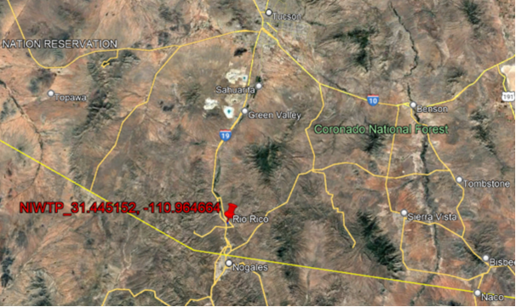
- The work is located completely within the United States, approximately nine (9) miles from the Mexican border.
  - Period of Performance
    - The period of performance shall be for a maximum of (120) days after the contract has been awarded to the Contractor.

Investigation of Site Conditions
- Contractors are encouraged to attend an agency organized site visit. Site visits may be scheduled by contacting Albert Flores at 520-281-1832 or cell 520-551-6564 or email Albert.Flores@ibwc.gov. While attending the site visit all contractors must adhere to personal protective equipment (PPE) steel toe footwear and hard hats. Contractors will not be permitted access to IBWC facilities without proper PPE.
Office hours are Monday through Friday, 7:30AM to 4PM, excluding Federal holidays.
Train tracks and Union Pacific switching station are sometimes occupied and blocking the access/egress to the plant. Alternative dirt road access is available.
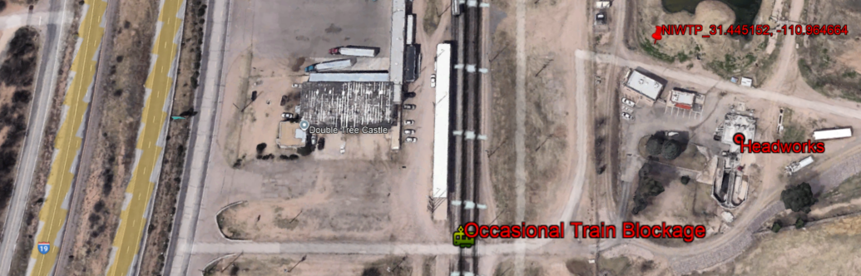
- Submission of a quote shall be conclusive evidence that the Contractor has reviewed, investigated, and acknowledged all items below.
  - Conditions bearing upon transportation, disposal, handling, and storage of materials.
  - The availability of labor, water, electric power, and roads.
  - Uncertainties of weather and similar physical conditions at the site.
  - The conformation and conditions of the ground.
  - The character of equipment and facilities needed for the performance of the work.
- Submission of a quote shall be conclusive evidence that the Contractor has investigated and is satisfied as to the conditions to be encountered, the character, quality, and work to be performed, and the quantities of materials to be furnished.
- Submission of a quote constitutes agreement that Contractor has provided written notice of all conflicts, errors, ambiguities, and discrepancies discovered in PWS, that responses to these written notices are acceptable to Contractor, and that PWS is enough to indicate and convey understanding of all terms and conditions for performing and furnishing required work.
- Contractor has the sole responsibility to make such independent investigation and examination as they deem necessary in order to satisfy themselves as to the conditions to be encountered in the performance of work and the quantities required to complete the work in accordance with the PWS.
- The Government assumes no responsibility for any understanding reached or representation made concerning conditions which can affect the work by any of its officers or agents before the execution of this Contract, unless that understanding, or representation is expressly stated in this Contract.
- Any failure of the Contractor to take the actions described and acknowledged in this paragraph will not relieve the Contractor from responsibility for estimating properly the difficulty and cost of successfully performing the work, or for proceeding to successfully perform the work without additional expense to the Government.

Duty to Inquire
- Contractor shall review the full PWS.
- If during review of these items, the Contractor finds discrepancies, omissions, conflicts, defects, errors, or ambiguities, they have a duty to inquire and shall notify the Contracting Officer prior to the question submission deadline as established in the solicitation. The Contractor shall also inquire about items that are unclear or open to interpretation.
- The Contractor shall take no advantage of any item of which they have a duty to inquire.

Work Restrictions
- The Contractor is responsible for conducting business between the hours of 7:00 AM thru 3:30 PM, Monday thru Friday except Federal holidays or when the Government facility is closed due to local or national emergencies, administrative closings, or similar Government-directed facility closings.
- The Contractor may request different working hours and must do so in writing to the Contracting Officer Representative (COR). USIBWC will make final determination as to the approval of a different work schedule.

SECTION 2 PROJECT REQUIREMENTS

General
- The Contractor will ensure that the headworks at the NIWTP is fully functional/operational. The Contractor shall furnish and install one new (1) Coarse Screen, two new (2) Fine Screens, and furnish and install two (2) Washing Presses (2). Furnish and install worn-out parts and replace them with the new comparable replacement equipment. One Fine screen has already been removed, and the space is ready for one new one. Both washing presses will replace two existing conveyor systems that will need to be designed and installed.
- There are currently two trains, with one coarse screen, one fine screen in place and one removed, and one grit pump currently in place. Additional new grit pump is in place but is currently unused.
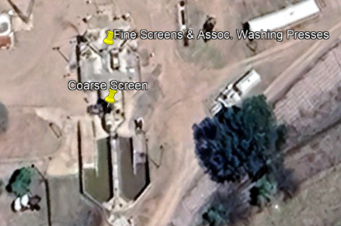
- The Contractor shall replace the existing one (1) coarse screen, two (2) washing presses, two (2) fine screens, and replace used wear parts with an equal or equivalent to existing model.
- The Contractor shall provide detailed cost breakdown to include all equipment, supplies, manuals, and service required to provide on-site preventative maintenance.
- The Contractor shall submit a Job Safety Analysis (JSA) Form filled out to be reviewed by NIWTP Personnel.
- Conduct a Safety Meeting with all the personnel involved in the project and Power Plant Personnel prior to start the project.
- The Contractor shall conduct a Safety Meeting with all the personnel involved in the project and Power Plant Personnel prior to starting the project. In addition, daily safety meetings shall be conducted at the start of each workday.
- As noted in Section 10:
INVOICE PROCESSING PLATFORM (IPP) is the electronic invoicing and payment method of invoicing

Clean-Up and Disposal of Waste Materials
- The Contractor shall be responsible for the cleanup and disposal of waste materials and rubbish from the site, field office(s), and staging area(s). Used equipment will remain on site.
- The disposal of waste materials and rubbish shall be in accordance with applicable Federal, State, and local laws and regulations and with the requirements in this Contract. Should a conflict exist in the requirements for cleanup and disposal of waste materials, the most stringent requirements shall apply.
  - All waste unless otherwise noted in these specifications shall be disposed of at a licensed landfill or waste disposal facility.
  - Recyclables
    - The recyclable and reusable products, equipment and materials shall remain property of the Government.
    - Scrap metal shall remain property of the Government.
- No excess materials shall be deposited within Government property, unless compliance confirmed by the Government.
- The Contractor shall maintain work and storage areas free from accumulations of waste materials and rubbish and before completing the work, and shall remove all temporary facilities, including, buildings, unused materials, concrete forms, and other like materials, which are not a part of the permanent work.

Testing and Training
The Contractor shall test the new system and provide training to power plant personnel at project completion prior to project acceptance. The functional testing shall be observed by the COR for verification and approval.
- If require prior to Contract closeout, the Contractor shall provide a comprehensive project-specific Government personnel training program for the systems and equipment designed and installed under this Contract.
- When operating procedures are not detailed in owner’s manuals, the Contractor shall write SOPs. These SOPs shall be available prior to the scheduled training provided below.
  - The Contractor shall furnish factory-trained representatives as required to conduct training sessions on the operation and maintenance of constructed works. The trainers shall be qualified in providing all required training and have expert knowledge of all aspects of the operation and maintenance of their systems and associated components.
  - The Contractor shall furnish all necessary training materials and furnish each student with a detailed and comprehensive manual covering all course subjects.
  - Training materials shall become the property of the Government after completion of the training.
  - Attendance at this training course will not exceed twelve (12) Government personnel. The training sessions shall be conducted at the Amistad Power Plant Office / worksite or at a Government provided classroom.
- Training shall include the components listed below:
  - Basis of system design, operational requirements, and criteria.
  - Documentation and use of O&M Manuals.
  - Relevant health and safety issues.
  - Emergencies, including warnings, trouble indications, shutdown and special operating instructions.
  - Operations - Start-up, normal operation, shutdown, unoccupied operation, seasonal changeover, manual operation, controls set-up and programming, troubleshooting, and alarms.
  - Adjustments.
  - Troubleshooting.
  - Maintenance as well as special maintenance and replacement sources.
  - Repairs, including diagnostic instructions, disassembly, and instructions for identifying parts and components.

Warranty
- The Contractor shall warrant that work performed under this PWS conforms to the Contract requirements and is free of any defect in equipment, material, or workmanship performed by the Contractor or any subcontractor or supplier at any tier for a period of at least one (1) year from project acceptance.
  - The Contractor is responsible for providing warranties on items when the manufacturer's warranty is less than the time indicated or when the manufacturer's warranty does not cover full repair and/or replacement as appropriate.
- The Contractor shall obtain warranties from responsible subcontractors, suppliers, and manufacturers, within sixty (60) days after completion of the applicable item of work, but no later than the date of warranty commencement. The minimum warranty period for any item shall be one year from acceptance.
- Starting date of warranty is date of Government acceptance of the work.
- A warranty requires that if a warranted item fails to meet Contract requirements, it shall be repaired, replaced, or have other remedial actions taken to bring the item into compliance with the Contract requirements. Any item damaged due to failure or malfunction of item warranted under this Contract shall be repaired or replaced at no cost to the Government.
- The Contractor shall supply the CO with a telephone number, mailing address, email address, and contact name for the point of contact for any required warranty work.

SECTION 3 EXISTING CONDITIONS

General
The existing equipment and system are currently mostly inoperable due to wear but will be left on site for future rehab. The only thing currently operating is the one coarse screen and associated conveyor system.
Influent flows to the NIWTP are approximately 15 Million Gallons per Day (MGD). Flows are managed in either one of two trains, which allows the other side to be taken offline.
Plumbing and electrical service are functional.
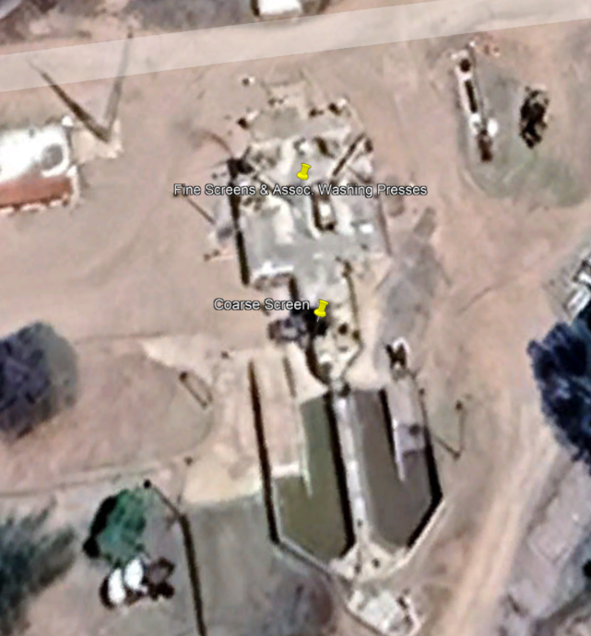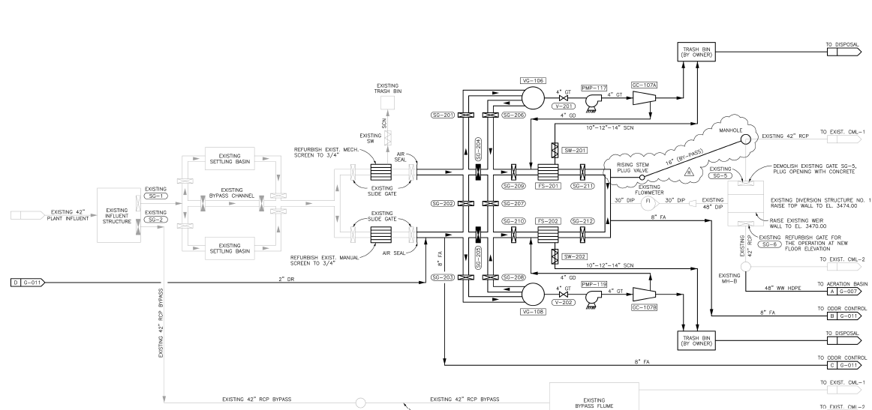

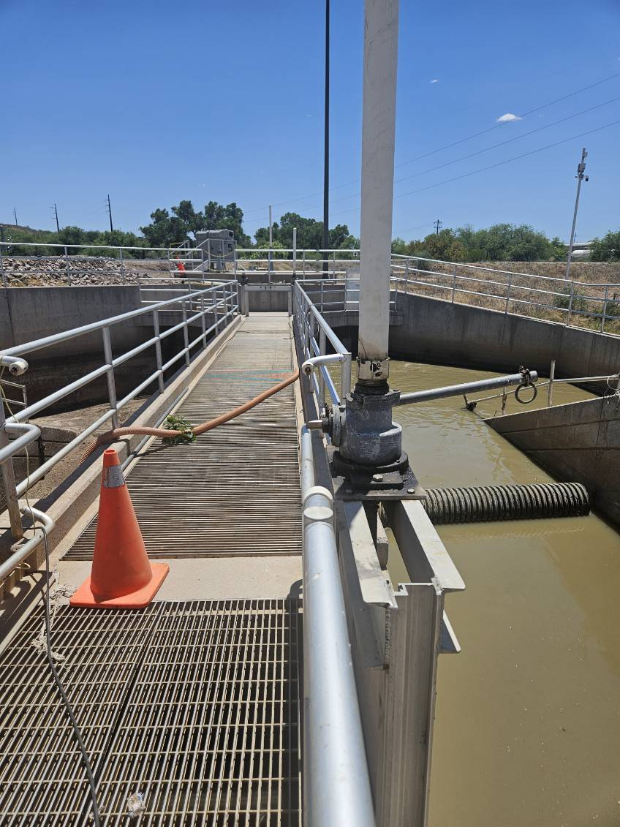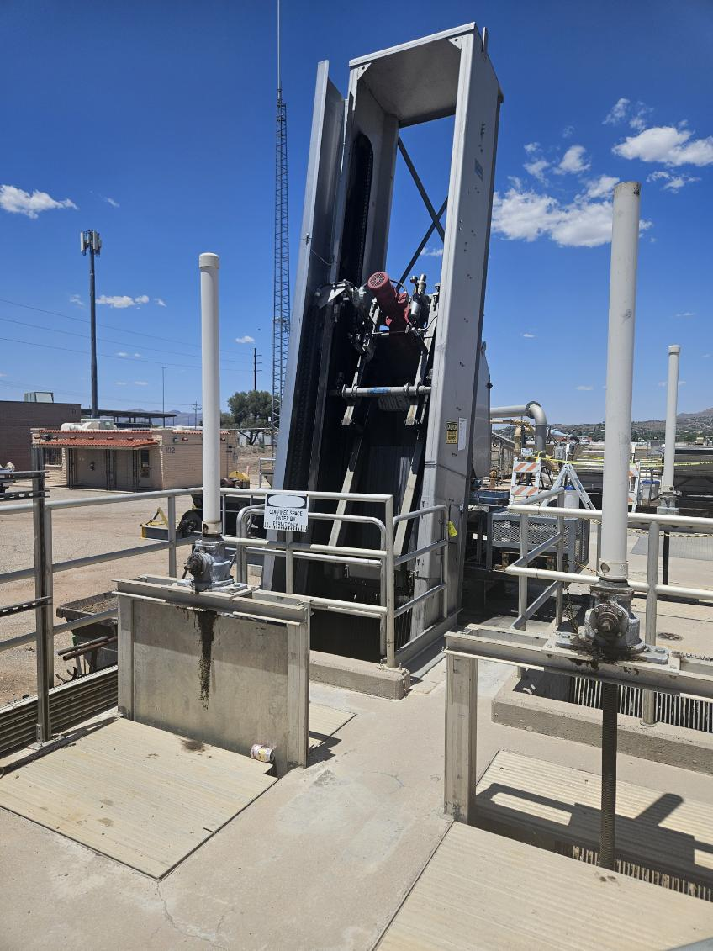
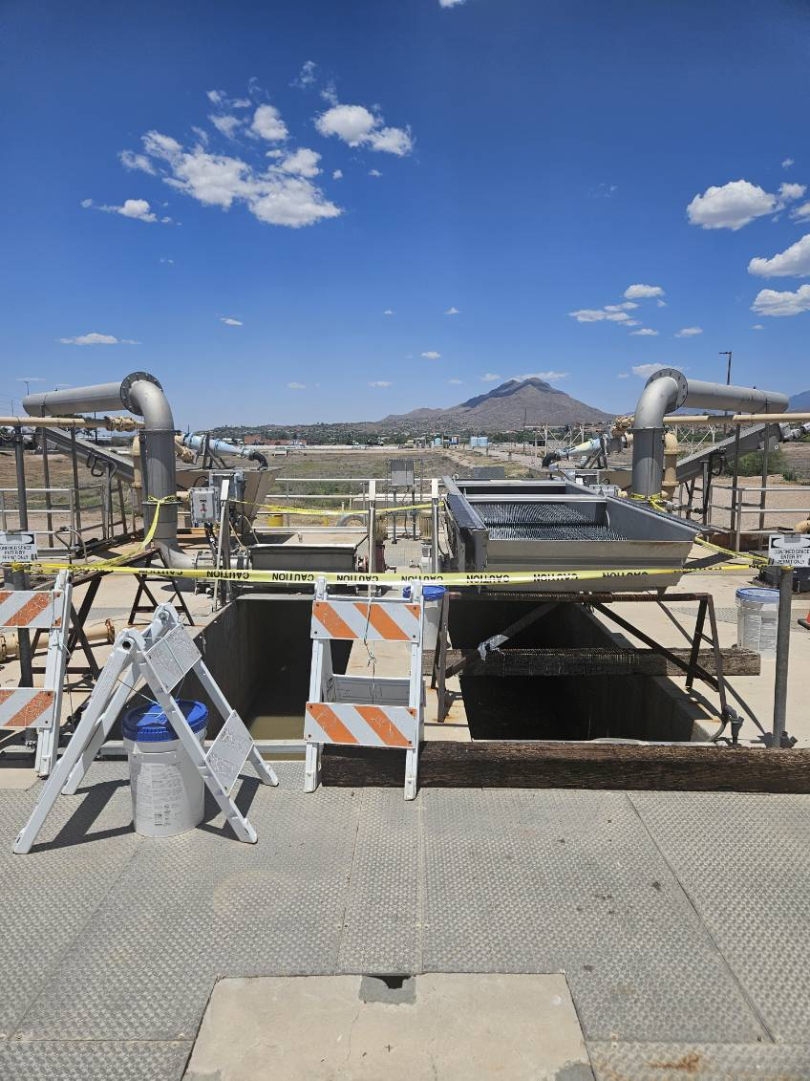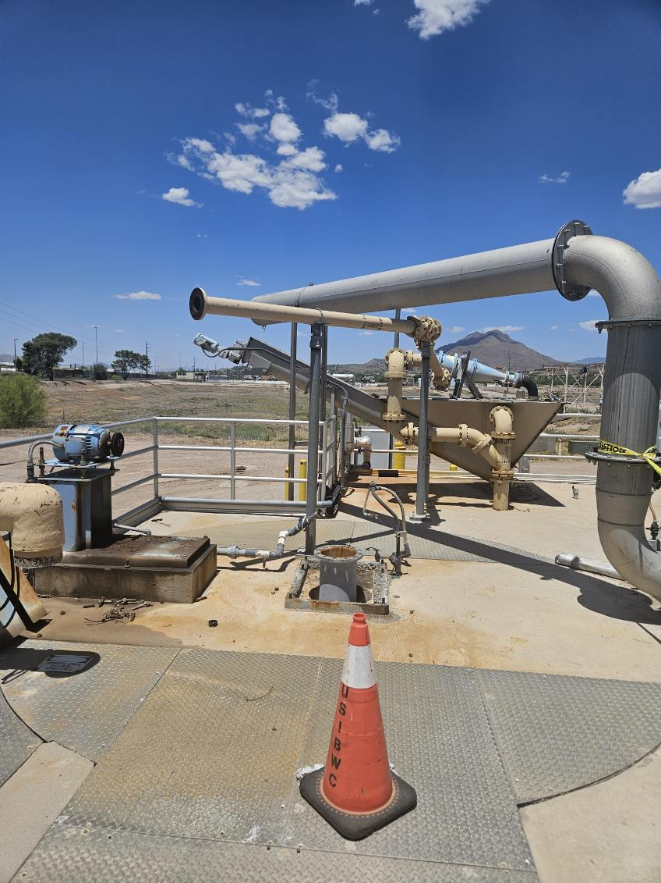
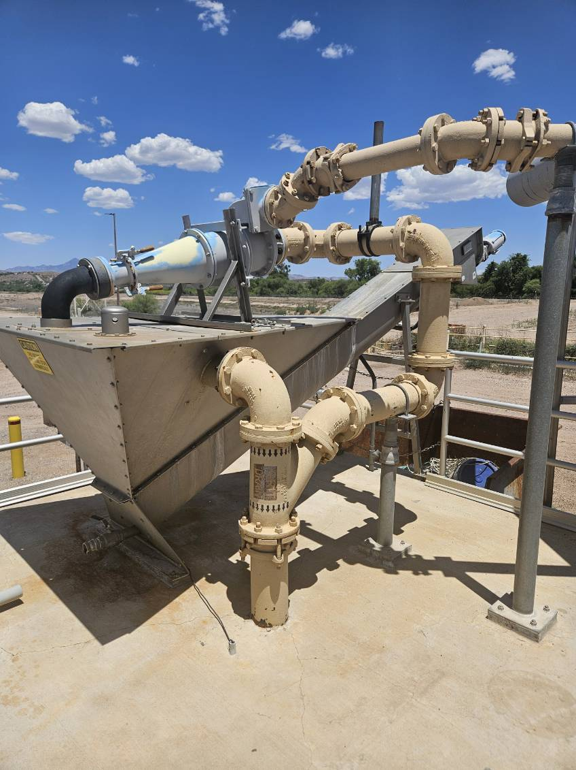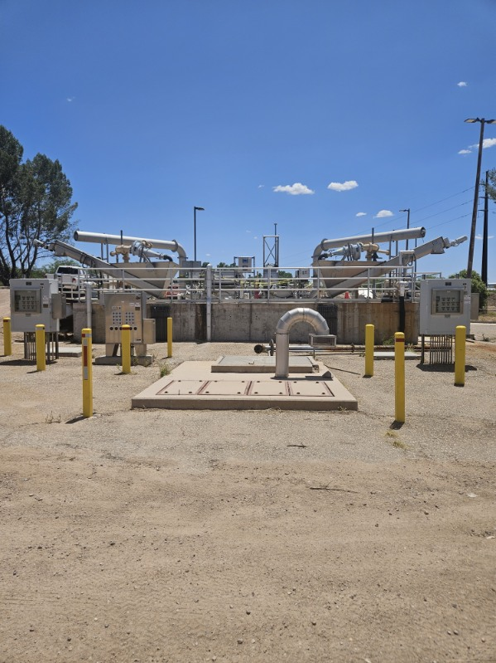

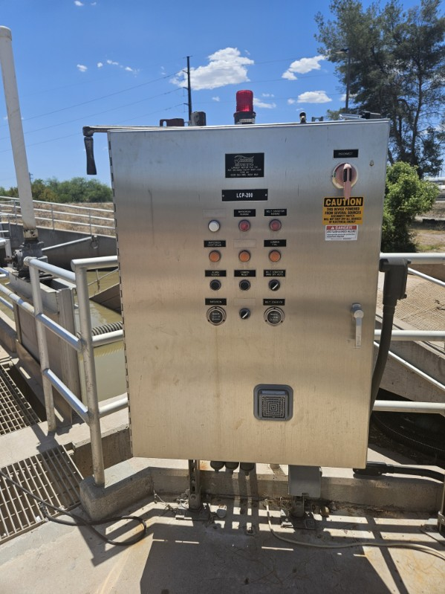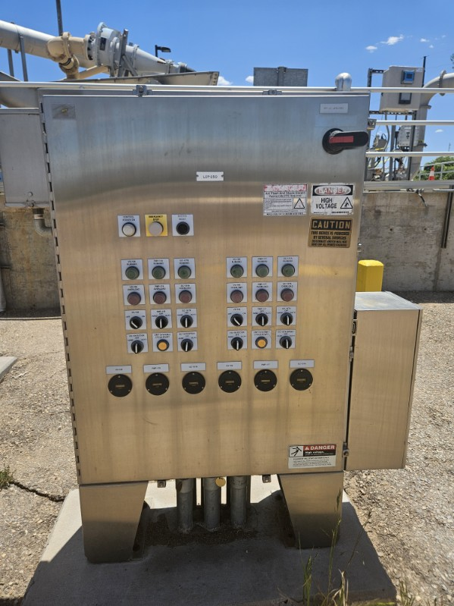
(More pictures included in the attachments)

Government Furnished Utilities
    - The Government will not be furnishing any equipment, material, services or utilities for this project.

Use of Government Land
- USIBWC property is available for use as the Contractor's staging and/or storage areas, subject to the approval of the COR.
- Housing for Contractor personnel will not be permitted on Government land.

Hazardous Materials
A. Although not classified as a hazardous material, raw sewage is a biohazard. No existing hazardous materials have been identified in this project.

SECTION 4 QUALITY REQUIREMENTS

4.1 Common Product Requirements
- Materials Certification
The Contractor shall submit a materials certification package to COR which contains a checklist and supporting documentation for all materials used on the project. The supporting documentation shall consist of a summary of all documentation practices utilized for material acceptance and explanations of any deficiencies noted on the checklist.
  - Material certifications shall ensure that all items meet the Buy American Act (41 USC 10a - 10d).
- Source Control
  - The Contractor shall use only materials that meet the Contract requirements. Vulcan and Mensch are the existing brands of equipment and are to be replaced in-kind to match existing equipment.
  - Unless otherwise specified or compliance confirmed, the Contractor shall use new materials for the work. Material can be reused onsite upon written approval of COR.
  - All materials installed shall be free of defects.
  - The Contractor shall secure the Government’s compliance confirmation of the proposed source of materials to be used before their delivery.
- Quality Control / Quality Assurance of Materials
  - The contractor shall ensure all equipment is fully operable and functioning as originally designed for the NIWTP.
  - Source Limitations
To the greatest extent possible for each item of work, the Contractor shall provide materials of a singular generic kind from a single source.
  - Compatibility of Options
Where more than one choice is available as options for Contractor's selection of a product, material, or equipment, the Contractor shall select an option which is compatible with other products, materials, or equipment. Compatibility is a basic general requirement of product, material, and equipment selections.
  - Field Measurements
Verify field measurements, lines, grades, locations, and details at the jobsite prior to fabrication. It shall be the Contractor's responsibility to conform to and satisfy actual field conditions, for accuracy of dimensions, proper fit, and for adequacy of use intended.
  - The Contractor shall correct or remove materials that fail to meet Contract requirements or that do not produce satisfactory results. The Contractor shall reimburse the Government for cost incurred if additional quality assurance sampling and testing is required by a change of source.
  - Materials not meeting Contract requirements will be rejected, unless the Government approves corrective actions in writing. Upon rejection, the Contractor shall immediately remove and replace rejected materials. Should the Contractor fail to comply with the removal of rejected materials, the Government may remove and replace defective material, and the cost of testing, removal, and replacement will be deducted from the Contractor’s final payment.
- Hazardous Materials
The Contractor shall use materials that are free of hazardous materials. The Contractor shall notify the Government immediately when a visual observation or odor indicates that materials in required material sources or on sites owned or controlled by the Government may contain hazardous materials.
- Surplus Materials
  - The Contractor shall leave surplus used equipment and rebuildable materials.
  - The Contractor shall remove and dispose of trash/packing materials in accordance with this PWS. If requested or otherwise noted in these specifications, the Contractor shall provide an appropriate level of documentation to verify proper disposal.
- Storage and Protection
  - Designate receiving/storage areas for incoming products so that they are delivered according to installation schedule and placed convenient to work area to minimize waste due to excessive materials handling and misapplication.
  - Store and protect products in accordance with manufacturers' instructions.
  - Store with seals and labels intact and legible.
  - Prevent contact with material that may cause corrosion, discoloration, or staining.
  - Provide equipment and personnel to store products by methods to prevent soiling, disfigurement, or damage.
  - The Contractor shall store and handle materials to preserve their quality and fitness for the work and shall store materials so that they can be easily inspected and retested. When required by the Government, the Contractor shall protect the material with cover, on wooden platforms, or on other hard, clean surfaces as necessary.

SECTION 5 DELIVERABLES

5.1 General
- Deliverables include, but are not limited to:
  - Project Schedule
    - Project Schedule is to be delivered to COR within seven (7) Calendar Days of contract award.
  - Licenses and Certifications
    - The Contractor shall submit all Licenses and Certifications required to perform this project specified in this PWS.
  - System Design
    - All system designs shall be approved by the Treatment Plant Area Office Manager (AOM) prior to installation.
  - Installation Procedure Plan
    - The Contractor shall provide a procedure to perform this work without disturbing power plant daily operations.
  - Material and equipment certifications
  - Product submittals provided for equipment and materials.
  - Safety documents
  - Warranty
  - Training
    - Training Manuals Two hard copies and electronic files
    - O&M Manuals two (2) hard copies and electronic files of the manuals, drawings, and as-builts.
    - Service Manuals two hard copies and electronic files
- Key Commissioning Steps

1. Pre-Commissioning Checks
- Verify all design and installation specifications match the approved plans.
- Confirm hydraulic profiles, pump station elevations, and screen velocities are correct to avoid issues like high flow velocities through screens Wastewater Digest.
- Inspect all components (screens, grit chambers, pumps, flowmeters) for proper alignment, clearances, and serviceability Wastewater Digest+1.

2. Hydraulic Testing
- Conduct pump station performance tests to ensure correct flow rates and head pressures.
- Test screen performance under designed flow conditions, adjusting velocities if necessary to prevent fouling Wastewater Digest.
- Validate grit removal efficiency (e.g., 95%+ in modern facilities) Walsh Group.

3. Equipment Startup Sequence
- Start pumps and screens in the correct sequence to avoid cavitation or mechanical stress.
- Test automated systems (e.g., self-cleaning bar screens) to ensure they operate as designed www.waterandwastewater.com.
- Calibrate flowmeters and control systems for accurate measurement and distribution.

4. Operational Testing
- Run the headworks under normal and wet weather conditions to verify capacity and reliability.
- Monitor for leaks, abnormal noise, or vibration in pumps and screens.
- Check odor control systems (especially in urban or sensitive areas) Walsh Group.

5. Performance Validation
- Measure and record key parameters: flow rate, solids removal efficiency, grit removal rate, and downstream equipment load.
- Compare results to design targets and adjust if necessary.

6. Training and Handover
- Train operators on headworks operation, maintenance, and troubleshooting.
- Provide documentation of test results, calibration records, and operational procedures.
7. Operational Readiness
The facility must be ready for routine operation, including:
  - Staff training and procedures for maintenance, cleaning, and emergency response.
  - Serviceability plans for screens, grit basins, and pumps Wastewater Digest.
  - Integration with the rest of the treatment train (e.g., flow distribution to primary or secondary processes).
8.Documentation and Sign-Off
Acceptance is formally documented with:
  - Test reports and performance data.
  - Signatures from the owner, designer, contractor, and regulatory agency.
  - Confirmation of budget and schedule adherence.

SECTION 6
PROJECT COORDINATION & ADMINISTRATION

General
- The Contractor shall provide all materials, equipment, labor, and services required by this Performance Work Statement to perform the work for the Contract sum and within the Contract period of performance.
- The Contractor shall be responsible for ensuring that all of its suppliers, manufactures and subcontractors have reviewed all applicable documents relative to their work. The Contractor shall provide all labor, material, equipment, and services not provided by the Contractor’s suppliers, manufacturers, fabricators, and/or subcontractors.

Security
The Contractor is responsible for securing the work site, equipment, and materials from vandalism and theft.

Safety
- The Contractor is solely responsible for worksite safety while performing work or inspections on Government property. The Contractor shall implement a safety program that protects the lives and health of personnel in the project area, prevents damage to property, and avoids work interruptions.
- The Contractor is responsible for being cognizant of and ensuring compliance with the requirements set forth. Such responsibility shall apply to both the Contractor’s operations and those of the Contractor’s subcontractors.
- The Contractor shall comply with all provisions of all applicable regulations of the Occupational Safety and Health Administration (OSHA), 29 CFR 1910, Occupational Safety and Health Standards, and 29 CFR 1926, Construction Standards.
  - The OSHA 29 CFR 1910 and 29 CFR 1926 can be accessed at http://www.osha.gov or http://www.gpo.gov/fdsys/.
- The Contractor’s personnel shall be required to use appropriate personal protective equipment such as, but not limited to hard hats, safety goggles, welding shields, face shields, protective footwear, protective gloves, and hearing protection.
- The Contractor shall perform and provide janitorial equipment and materials for the daily housekeeping.
- The Government will not provide trash bags and dumpsters.

SECTION 7 PROJECT MEETINGS

General
- The Contractor, the COR, or the CO may schedule project meetings at any time.
- When USIBWC schedules a meeting, the COR shall inform participants and others involved and individuals whose presence is required, of date and time of each meeting. The COR shall prepare the meeting agenda and distribute to all invited attendees.
- When the Contractor schedules a meeting, the Contractor shall inform participants and others involved and individuals whose presence is required, of date and time of each meeting. The Contractor shall prepare the meeting agenda and distribute to all invited attendees.
- The following meetings are anticipated, and the Contractor shall identify them in the Schedule:
  - Kickoff Meeting
  - Progress Meetings

Kickoff Meeting
- After award of the Contract, the COR will coordinate with the Contractor and schedule a Kickoff Meeting. The meeting shall take place prior to the beginning of any Contract work.
- The purpose of the meeting is to introduce project personnel and to review responsibilities and procedures.
- The Contractor shall reach an understanding with the Government regarding the project requirements as stated is this Performance Work Statement. This understanding shall be documented in writing and approved by the CO after the Kickoff Meeting.
- Attendees include, but are not limited to:
  - Contractor's Project Manager
  - CO
  - COR
  - Nogales International Wastewater Treatment Plant Representative
  - It is recommended that Contractor's engineers, inspectors, subcontractors, suppliers, and other parties concerned also attend the conference. The Contractor may invite anyone they wish to this meeting.
  - All participants at the conference shall be familiar with the project and authorized to conclude matters relating to the work.
- Agenda
Discussion of items of significance that could affect the work and project, including the following:
  - Introduction/designation of key personnel and their duties.
  - Review of the current phasing, critical work sequencing, and long-lead items.
  - Review of minimum project requirements.
  - Review of procedures for handling and processing modifications, RFIs, deliverables, and applications for payment.
  - Preparation of deliverable documents.
  - Use of site.
  - Work restrictions.
  - USIBWC and other's occupancy requirements.
  - Safety and first aid.
  - Security.
  - Maintenance of project site.
  - Working hours.
- Meeting Minutes
The Contractor and COR will record the discussions of the meeting and distribute the minutes to all attendees for review prior to finalizing.

Progress Meetings
- If needed, the Contractor or COR will schedule progress meetings once the Contractor has mobilized onsite. The COR will conduct and issue minutes of the meetings. Meeting minutes will become official Contract correspondence.
- The Government may call other meetings on an "as needed" basis.
- The purpose of these meetings shall be to analyze the progress of the work, resolve conflicts, and in general coordinate the operation of all organizations active at the project site.

SECTION 8 PROJECT SCHEDULE

8.1 Description / Purpose
- The Contractor shall prepare a project schedule which shall reflect completion of all work under this Performance Work Statement.
- Project schedule submittal shall include an electronic pdf file.
  - All abbreviations shall be defined.
  - Each project schedule shall show a revision date.
- Baseline Schedule Preparation
Prepare a list of all activities required to complete the work. The baseline schedule shall include all planned work activities and sequences and show Contract completion within the number of calendar days specified in the Contract.
- Activities
Prepare a list of all activities required to complete the work. Indicate the estimated duration, sequence requirements, and relationship of each activity in relation to other activities.
- Time Frame
Proposed duration assigned to each activity shall be the Contractor's best estimate of time required to complete the activity considering the scope and resources planned for the activity.
SECTION 9 REGULATORY REQUIREMENTS

Contractor's Responsibility
- It is the Contractor’s responsibility to perform work in compliance with all applicable requirements of federal, state, and local laws, codes, rules, regulations, ordinances, and standards, including, but not limited to, those outlined in 9.4 below.
- It shall be the responsibility of the Contractor to acquire copies of all applicable codes, regulations, and standards for ready reference.
- In instances where requirements are in conflict, the stricter standard shall apply.
- All inspections, observations, or tests required for code compliance are the responsibility of the Contractor.

Permits
- Prior to the beginning of work, the Contractor shall be responsible for researching, coordinating, obtaining, and paying all applicable fees for all permits required by Federal, state, and local entities. The Government is not responsible for any existing or newly introduced permits required before, during and/or after work on this project.
- The Contractor shall be responsible for and shall give and maintain all notices required by applicable regulations, laws, or permitting authorities pertaining to work on of this project.

Dates
- For all related standards and regulatory requirements in this document, the version, edition, or year shown indicates the governing version.
- All Public Laws, Code of Federal Regulations (CFR), Federal Acquisition Regulation (FAR), Executive Orders (EOs), Management Policies, Government Directives, Government Standards, refer to the original document as well as any subsequent amendments, corrections, and/or additions.
  - The latest amendments, corrections and additions are to be assumed applicable in the same way as the document itself.
  - The version in effect as of the issuing date of the Solicitation for this project governs unless the law, regulation, order, policy, directive, or standard is updated with a retroactive clause.

Summary of Regulatory Documents and Agencies
Regulatory requirements applicable to this project include, but is not limited to, the items listed below.
- Institute of Electrical and Electronics Engineers (IEEE)
  - 2017 National Electrical Safety Code (NESC)
- National Fire Protection Association (NFPA)
  - NFPA 70-2017 Standard for Electrical Safety in the workplace (also known as the National Electrical Code [NEC]), with Errata through 70-17-4 and TIA through 17-4
- Occupational Safety and Health Administration (OSHA)
  - Occupational Safety and Health Standards (29 CFR 1910)
    - https://www.osha.gov/law-regs.html
  - Construction Standards (29 CFR 1926)
    - https://www.osha.gov/pls/oshaweb/owasrch.search_form?p_doc_type=STANDARDS& p_toc_level=1&p_keyvalue=Construction
- Public Laws and Acts:
All Public Laws and Acts can be found at http://www.gpo.gov/fdsys/
  - Buy American Act [41 USC 10a - 10d]
  - National Environmental Policy Act (NEPA) [42 USC 4321-4347]
  - Resource Conservation and Recovery Act (RCRA)
  - Solid Waste Disposal Act
  - Toxic Substance Control Act
- State of Texas
  - Texas Engineering Practice Act and Rules Concerning the Practice of Engineering and Professional Engineering Licensure
    - http://www.tbpe.state.tx.us/downloads/law&rules.pdf

SECTION 10 MEASUREMENTS AND PAYMENTS

10.1 USIBWC Payment Processing
A. The Contractor shall submit invoices via the Invoice Processing Platform (IPP) System. IPP is a web-based system that provides one integrated, secure system to simplify the management of vendor invoices. It is offered at no charge to federal agencies and their vendors. Further information on IPP will be provided at time of award.
B. The invoices for this Contract shall not be combined with any other work or other contracts. They shall be for this Contract only.

Schedule of Values
- Breakdown each lump sum item into component work activities used in the schedule for which invoices may be requested. The work activities broken out within the Schedule of Values shall be integrated into and made a logical part of the baseline schedule submitted under this section.
    - The total costs for the component work activities shall equal the Contract price for that lump sum item.
    - Overhead, general, and administrative expenses, escrow, bonds, profit, and other across the board markups shall be applied to each line in the Schedule of Values uniformly.
    - An unbalanced Schedule of Values providing for overpayment to the Contractor for items of work to be performed first will not be compliance confirmed but shall be revised by the Contractor and resubmitted until acceptable to the COR. If requested by the Government, the Contractor shall furnish full copies of subcontracts showing actual costs.
    - The Government may request data to verify accuracy of dollar values.
- Do not break down unit price items. Use only the Contract price for unit price items.
- An acceptable Schedule of Values shall be agreed upon by the Contractor and COR before the first invoice is processed.
- The following items shall have an entry in the Schedule of Values. The Contractor may breakdown each item listed into subsections if they so choose. The Contractor may add additional items. The items shown are the minimum required.
    - Mobilization/Demobilization and receiving of parts
    - Installation and aligning/leveling
    - Electrical Testing
    - Testing of Equipment and Training
10.2 Progress Payment (Lump Sum CLIN)
- The Schedule of Values shall be used to prepare an invoice request for the items, or portions of items, of the work completed during the monthly progress period.
- The Contractor may receive a progress payment for material delivered to the project site and accepted by the COR.
- As the activity progresses, the Contractor will be paid the value based on the percentage associated with the activity in the Schedule of Values.

--End of Performance Work Statement--

