PICTURE 1
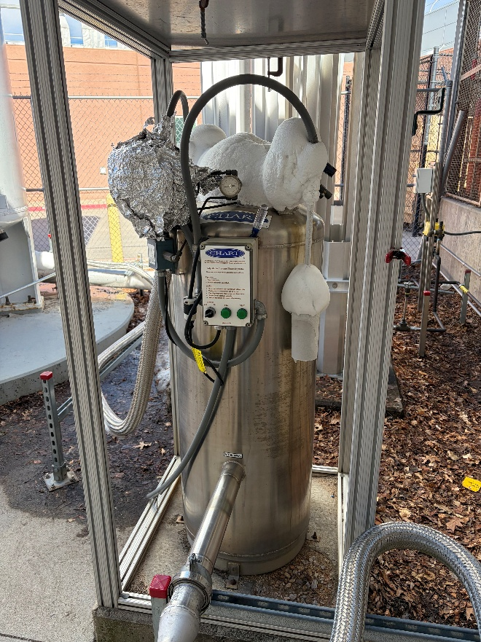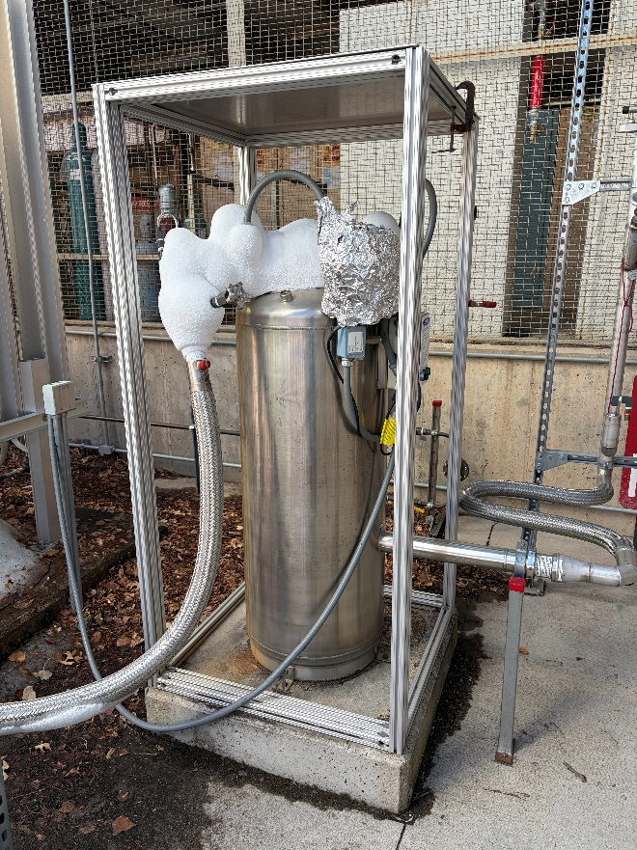
Photographs of NIST’s Existing APPS Unit

PICTURE 2
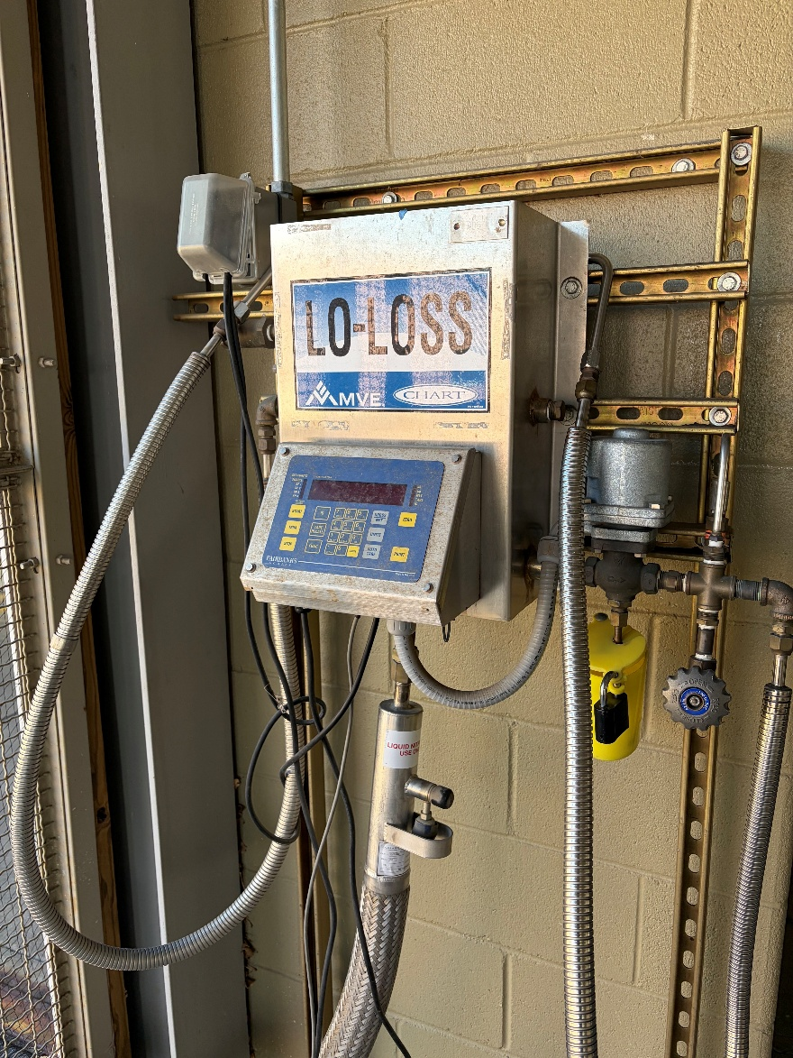
Photograph of NIST’s Existing Liquid Nitrogen Fill Station

