Artwork and Text Requirements
Food Service Uniforms – USS Theodore Roosevelt (CVN 71)
1. General
1.1 All logos and text may be applied using sewn embroidered patches, direct embroidery, and screen print where applicable.

2. Culinary Specialist (CS) T-Shirts
2.1 Standard CS T-Shirts – Front
2.1.1 Front chest logo (left):
- CVN-71 insignia
- Approximate height: 3.5–4 inches
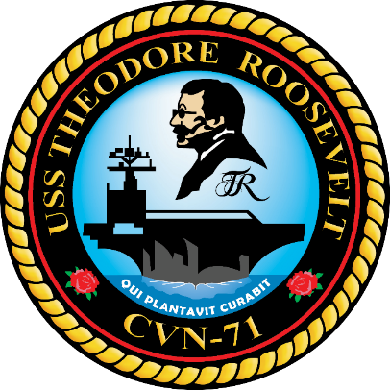
2.2 Standard CS T-Shirts – Back
2.2.1 Large back logo (middle):
- Culinary Specialist logo
- Approximate size: 10–12 inches

2.3 Khaki CS T-Shirts – Front
2.3.1 Front chest logo (left):
- CVN-71 insignia
- Approximate height: 3.5–4 inches
- Chief crest above ship crest for khaki shirts
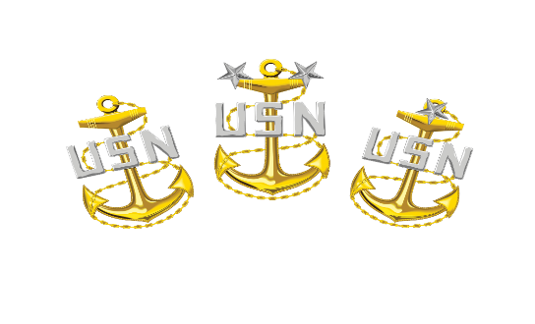

2.4 Khaki CS T-Shirts – Back
2.4.1 Back of khaki shirts:
- Large back logo (middle): Culinary Specialist logo
- Approximate size: 10–12 inches

2.5 CS T-Shirt Back Text Variants
2.5.1 The following back text appears in Attachment 1 for CS shirts:
- RECORDS KEEPER
  - Large black text "RECORDS KEEPER"
  - Approximate size: 10–12 inches
  - Middle placement

- ADMIN
  - Large black text "ADMIN"
  - Approximate size: 10–12 inches
  - Middle placement

- IRT
  - Large black text "IRT"
  - Approximate size: 10–12 inches
  - Middle placement

- CARGO
  - Large black text "CARGO"
  - Approximate size: 10–12 inches
  - Middle placement
- MAINTENANCE
  - Large Red text “MAINTENANCE”
  - Approximate size: 10–12 inches
  - Middle placement
3. Food Service Attendant (FSA) Shirts and T-Shirts
3.1 FSA Regular Shirts / T-Shirts – Front
3.1.1 Front chest logo (left) for regular shirts:
- CVN-71 insignia
- Approximate height: 3.5–4 inches
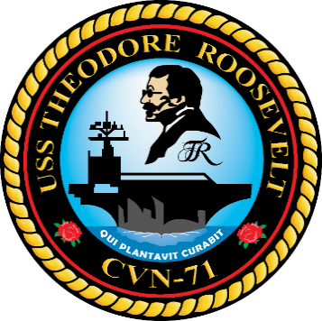
3.1.2 Large front text:
- FOOD SERVICE ATTENDANT
- Yellow accent
3.2 FSA Collared Shirts – Front
3.2.1 Front chest logo (left) for collar shirts:
- MDMAA badge
- Approximate height: 3.5–4 inches
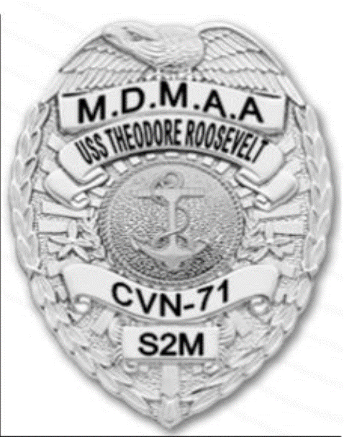
3.3 FSA Shirts – Back
3.3.1 Large back text for regular shirts:
- FOOD SERVICE ATTENDANT
- Yellow text
- Middle placement
- Approximate size: 10–12 inches
3.3.2 Additional back text variant:
- MDMAA
- Yellow text
- Middle placement
- Approximate size: 10–12 inches

4. Culinary Specialist (CS) Chef Coats
4.1 Front of Coat
4.1.1 Front chest logo (left):
- CVN-71 insignia
- Approximate height: 3.5–4 inches
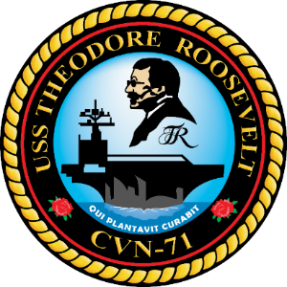
4.2 Front Text Under Logo Embroidery
4.2.1 Red chef coats:
- Front text under logo embroidery: CHIEF MESS
- Gold accent 4
4.2.2 Dark green chef coats:
- Front text under logo embroidery: WARDROOM
- Gold accent 4
4.2.3 All other chef coats:
- Logo only
- No additional front text specified
4.3 Back of Coat
4.3.1 Back of coat:
- N/A
- No back artwork/text specified

5. Cargo Pants
5.1 No separate logo, artwork, or text placement instructions for cargo pants were visible in the retrieved Attachment 1 artwork content. Cargo pants appear to be specified by size, color, fabric, and quantity only.

