EXISTING CONDITIONS
All provided measurements are estimated and should be reviewed prior to placing orders.

Group Room: New windows
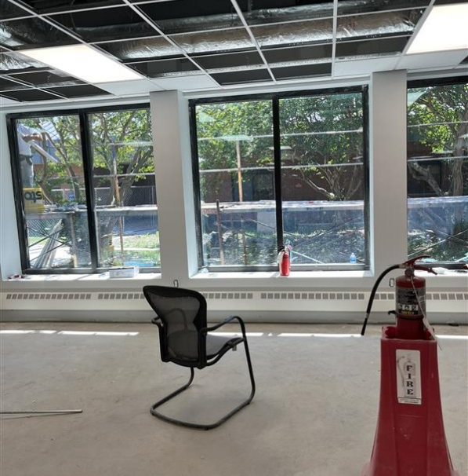

General Office Areas:
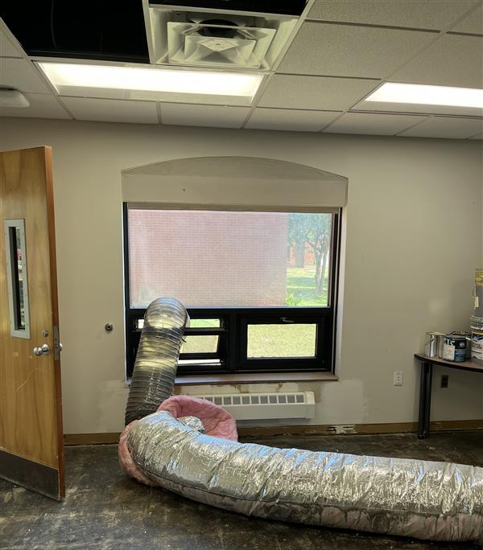

Gym/Rec Area:
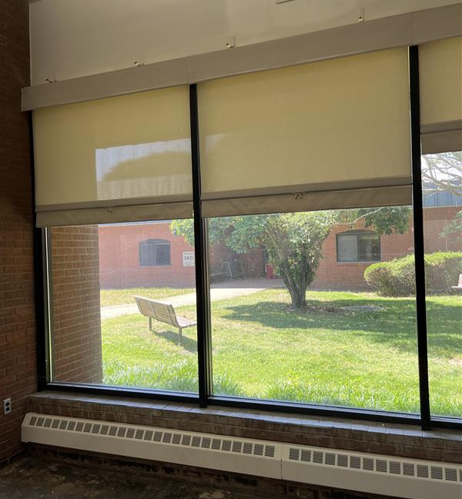

Bldg 33 Conference Room:
