Section L Instructions to Offerors
Simplified Acquisition of Base Engineering Requirements (SABER)

11 September 2026

Table of Contents

- Proposal Preparation Instructions 5
- Budget/Funding Information 6
- GENERAL INSTRUCTIONS 6
    - Include Sufficient Detail 6
    - Embellishments 7
    - Proposal Acceptance Period 7
    - Government Contract Files 7
    - Point of Contact 7
    - Debriefings 7
      - Pre Award Debriefings 7
      - Post Award Debriefings 8
    - Discrepancies 8
    - Electronic Reference Documents 8
    - Oral Presentation 8
    - Amendments to Solicitation 8
    - Submission, Modification, Revision, and Withdrawal of Proposals 8
      - Receipt of Proposal 8
      - Proposal Withdrawal 9
      - Title Page 9
      - Proposal Organization 9
      - Page Limitations 10
      - Pricing Information 10
      - Cross Referencing 10
      - Cross-Reference Matrix 10
      - Indexing 10
      - Page Size and Format 10
      - Electronic Offers 11
- Volume I – Price (Factor 1) 11
  - General Instructions 11
    - Total Evaluated Price (TEP) 11
    - Seed Project Pricing 12
    - Cost or Pricing Information Requirements 12
    - Rounding 12
    - Pricing Assumptions 12
    - Estimating techniques and Methods 12
    - Construction Wage Rate Requirement Wage Determinations 12
- Volume II – Technical (Factor 2) 12
  - General Instructions 12
    - Adequate Responses 13
    - Volume Organization 13
  - Technical Acceptability 13
    - Subfactor 1: Seed Project 13
    - Subfactor 2: Subcontractor Utilization Plan 15
    - Subfactor 3: Management Plan 15
    - Subfactor 4: Quality Control Plan 15
  - Volume III – Past Performance 15
  - General Instructions 15
    - Recency 16
    - Relevancy 16
    - Past Performance Discrepancy 16
    - Joint Venture 16
  - Volume IV, Part I – Contract Documentation 17
  - General Instructions 17
    - Model Contract/Representations and Certifications 17
    - Section A – Solicitation/Contract Form 17
    - Section B – Supplies or Services and Cost/Prices 17
    - Section I – Contract Clauses 17
    - Section K – Representation, Certifications, and other Statements of Offerors
17
  - Other Information Required 18
    - Site Visit Attendees 18
    - Authorized Offeror Personnel 18
    - Small Business and Joint Venture 18
  - Exceptions to Solicitation Requirement 18
  - Volume IV Part II – Contractor Responsibility 19
  - General Instructions 19
    - Ability to Obtain Adequate Financial Resources 19
    - Limitations on Contracting 19
    - Bona Fide Office 19
    - Contractor Compliance With the Cybersecurity Maturity Model 19
Appendix 1 – PIEE Solicitation Module Instructions 20
Step by Step Instructions 21
New User 21
Existing User 27
Help 28
Getting Started 28
Account Support 28
Technical Support 28
Roles and Actions/Functions Matrix 28
Appendix 2 – Cross Reference Matrix 30

List of Tables
Table 1: Proposal Organization 9
Table 2 Solicitation Exceptions 18

Proposal Preparation Instructions

This acquisition will utilize Lowest Price Technically Acceptable (LPTA) source selection procedures conducted in accordance with (IAW) Revolutionary Federal Acquisition Regulation (FAR) Overhaul (RFO) Part 15, Contracting by Negotiation, as supplemented by the Revolutionary Defense Federal Acquisition Regulation Supplement (R-DFARS), and Appendix C of the DoD Source Selection Procedures dated 20 August 2022 (Source Selection Procedures can be found under DFARS 215.300 on acquisition.gov). Technical tradeoffs will not be made, and no additional credit will be given for exceeding acceptability.

All regulatory and statutory references will align with the changes made in the RFO, accessible via acquisition.gov and the R-DFARS accessible via https://www.acq.osd.mil/dpap/dars/DFARS_FAR_overhaul_class_deviations.html.

To ensure timely and equitable evaluation of proposals, offerors must follow the instructions contained herein. Offerors are required to meet all solicitation requirements, including all stated terms, conditions, representations, certifications, and technical requirements, in addition to those identified as evaluation factors or subfactors. Offerors must clearly identify any exception to the solicitation terms and conditions and provide complete accompanying rationale.
Offerors shall submit all exceptions no later than (NLT) 30 days after the release of the solicitation.

Offeror questions must be submitted by September 25, 2026 and will be answered in a timely manner. Questions after this date may or may not be answered depending on the CO’s determination.

The offeror’s overall proposal shall consist of four (4) separate volumes:
    - Volume I – Price
    - Volume II – Technical
    - Volume III – Past Performance Information
    - Volume IV – Contract Documentation

Proposals, IDIQ and the Seed Project, must be received by the Contracting Officer using the PIEE Solicitation Module (see Appendix 1). Attention: Ms. Shelly Bachison and Capt Eric Tucker, no later than 5 November 2026 at 4:30 P.M. MT as stated in Section A of the solicitation.

PROGRAM STRUCTURE AND OBJECTIVES
Competition will be limited to 8(a) firms. The applicable geographic areas that the Hill AFB SABER contract services are Utah, Nevada, and Wyoming. IAW the SBA contiguous state rule, 8(a) firms competing on this project can establish their bona fide place of business in Arizona, California (Sacramento, Fresno, and Orange County), Colorado, Idaho (Boise District), Montana, Nebraska, Nevada, New Mexico, Oregon, South Dakota, Utah, and Wyoming.
Offerors with established places of business within the geographic areas listed do not need to establish or re-establish (Utah) reestablish a new bona fide place of business. Consistent with SBA Policy Notice No. 6000-874794, other 8(a) construction firms will be considered for this acquisition provided they can establish a bona fide place of business within the geographical competitive area within 60 days of contract award, under the assigned NAICS code.

However, the Government reserves the right to award more, fewer or no contract(s) at all if the Source Selection Authority (SSA) determines it is in the Government's best interest. The SSA will consider the Government's expected volume of work, available funding, competition adequacy, and the availability of best value proposals. The Government is not liable for any costs incurred as a result of this solicitation.

The Government intends to award without negotiations IAW RFO 15.105-2; therefore, it is imperative that offerors submit their best pricing and proposal terms. However, the Government reserves the right to hold negotiations if it is determined to be in the best interest of the Government. During negotiations an offeror’s responses to Evaluation Notices (ENs) and the Final Proposal Revision (FPR) will be considered in making the source selection decision.

Budget/Funding Information
Funds will not be obligated on the Basic IDIQ contract(s). Funding will be obligated on each task order awarded under the Basic IDIQ contract(s). The Government reserves the right to cancel this solicitation either before or after the closing date. In the event the Government cancels this solicitation, the Government has no obligation to reimburse an Offeror for any costs incurred.
The minimum guarantee for this contract(s) will be met with the issuance of the first task order upon execution of the basic IDIQ contract(s). This minimum guarantee will be fulfilled through the Post-Award/Safety Plan.

GENERAL INSTRUCTIONS
This section provides general guidance for preparing proposals as well as specific instructions on format and content. The offeror's proposal shall include all data and information requested and shall be submitted IAW these instructions. Any offeror who submits an incomplete package may be considered ineligible for award and eliminated from the competition. The offer shall be compliant with the requirements as stated in the Statement of Work (SOW), Seed Project SOW, Model Contract, and Solicitation. Non-conformance with these instructions shall result in an “Unacceptable” proposal evaluation.

Include Sufficient Detail
The proposal shall be clear, concise, and include sufficient detail for effective evaluation and for substantiating the validity of stated claims. The proposal shall NOT simply rephrase or restate the Government’s requirements, but rather shall provide convincing rationale to address how the offeror intends to meet these requirements. Offerors shall assume that the Government has no prior knowledge of their experience and certifications and will base its evaluation solely on the information presented in the offeror’s proposal.

Embellishments
Elaborate brochures or documentation, binding, detailed artwork, or other embellishments that do not address solicitation requirements are unnecessary.

Proposal Acceptance Period
Proposals submitted in response to this RFP will be valid for 120 days after receipt as specified in Block 13 of the Standard Form (SF) 1442.

Government Contract Files
The Government will retain digital copies of all proposals received IAW RFO 15.108.

Point of Contact
Exchanges of source selection information between Government and offerors will be controlled by the Contracting Officer (CO). Exchanges of source selection information after submission of the initial proposal packages between the Government and offerors will be controlled by the CO. Email may be used to transmit such information and must include “Source Selection Information – See RFO 2.101 and 3.104” in the subject line of the email IAW RFO 3.104-4(c). Specify "Basic IDIQ" or "Seed Project" at the beginning of the subject line to ensure prompt routing and response. The CO is the sole point of contact for this acquisition. Offeror shall address any questions or concerns they may have to the CO.

Written Request for clarification may be sent to the CO and Contracting Specialist at the emails below:

AFSC/OL:H/PZIOC
Contracting Officer: Shelly Bachison, shelly.bachison@us.af.mil Contracting Specialist: Capt Eric Tucker, eric.tucker.10@us.af.mil

Debriefings

Pre Award Debriefings
The CO will promptly notify offerors of any decision to exclude them from the competitive range IAW RFO 15.206-1(a), whereupon they may request and receive a pre-award debriefing in accordance with RFO 15.206-2.

Post Award Debriefings
The CO will notify unsuccessful offerors included in the competitive range of the source selection decision IAW RFO 15.207-2. Upon such notification, unsuccessful offerors may request and receive a debriefing. Successful offerors will be notified of the source selection decision and may also request a post-award debriefing IAW the requirements of RFO 15.301.

Discrepancies
If an offeror believes that the requirements in these instructions contain an error, omission, or are otherwise unsound, the offeror shall immediately notify the CO in writing with supporting rationale.
The offeror is reminded that the Government reserves the right to award this effort based on the initial proposal, as received, without negotiations IAW RFO 15.203.

Electronic Reference Documents
All referenced documents for this solicitation are available at http://www.sam.gov. Potential offerors are encouraged to subscribe for real-time e-mail notifications when information has been posted to the website for this solicitation.

Oral Presentation
Oral presentations will not be allowed.

Amendments to Solicitation
If this Request for Proposal (RFP) is amended, all terms and conditions that are not amended remain unchanged. Offerors shall acknowledge receipt of any amendment to this request by signing and returning the front page of each amendment with its proposal.

Submission, Modification, Revision, and Withdrawal of Proposals
Proposals and modifications to proposals shall be digital and shall be submitted through the PIEE solicitation module. Late proposals will only be considered IAW RFO 15.107(b). Proposals may be withdrawn by email received at any time before award.

Receipt of Proposal
Acceptable evidence to establish the time of receipt at the Government installation includes the digital time/date stamp of the PIEE solicitation module.

Proposal Withdrawal
Proposals may be withdrawn by email received at any time before award.

Title Page
The title page of each volume must show:

        - Solicitation Number
        - Company name, address, Commercial and Government Entity (CAGE) Code and Unique Entity Identification (UEI)
        - Primary point of contact name, telephone number and email address
        - Volume number and name (i.e. Volume I, Price)

Proposal Organization
The offeror shall prepare the proposal as set forth in the Proposal Organization Table below. The titles and contents of the volumes shall be as defined in this table, all of which shall be within the required page limits and with the number of copies specified. The contents of each proposal volume are described in the Section L paragraph as noted in the Table below:

Table 1: Proposal Organization

Volume | Section L Paragraph # | Title | Copies | Page Limit
I | 4.0 | Price | 1 (Original) | Unlimited (Pricing Assumptions  limited to 4 pages)
II | 5.0 | Technical | 1 (Original) | 60 pages (Excluding Seed  Project Material Submittals)
III | 6.0 | Past Performance | 1 (Original) | 3 pages per submission
IV | 7.0 | Contract Documentation | 1 (Original) | Unlimited

Page Limitations
Page limitations shall be treated as maximums. If exceeded, the excess pages will not be read or considered in the evaluation of the proposal. Page limitations may be placed on responses to Evaluation Notices (ENs) if applicable. The specified page limits for EN responses will be identified in the letters forwarding the ENs to the offerors. Each page shall be counted except the following: blank pages, title pages, tables of contents, tabs, glossary of abbreviations and acronyms, cross reference matrix, Seed Project Material Submittals, and those noted in Table 1, Proposal Organization, as “Unlimited.”

Pricing Information
All pricing information shall be addressed ONLY in the Price Volume.

Cross Referencing
Each volume of the proposal shall be written on a stand-alone basis so that its contents may be evaluated without cross-referencing to other volumes of the proposal. Information required for proposal evaluation that is not found in its designated volume will be assumed to have been omitted from the proposal.

Cross-Reference Matrix
The offeror shall fill out the proposal section of the cross-reference matrix in the format provided in Appendix II, Cross-Reference Matrix, of this document, indicating the proposal reference information as it relates to Section L, Section M and the SOW. The cross-reference matrix shall be included in the Technical Volume. The cross-reference matrix addresses each requirement within the SOW, Section L and Section M. The offeror shall fill in the proposal section independently labeled with the appropriate paragraph number from its proposal that addresses the requirement. The offeror’s cross-referencing matrix will not count against page limitations for its respected volume. The offeror’s approach shall address all requirements IAW the following Paragraphs and sub-paragraphs of the SOW unless otherwise noted

Indexing
Each volume shall contain a detailed table of contents to delineate the subparagraphs within that volume. Tab indexing shall be used to identify sections. Include an indexed list of tables and figures. Tables and figures do not count against the page limitations for their respective volumes. Glossary of Abbreviations and Acronyms; Each volume shall contain a glossary of all abbreviations and acronyms used, with an explanation for each. Indexes and glossaries do not count against the page limitations for their respective volumes.

Page Size and Format
A page is defined as each face of a sheet of paper containing information. Page size shall be 8.5 x 11 inches. Except for the reproduced sections of the solicitation document, the text shall be Times New Roman and font size shall be no less than 12 points and lines shall be single spaced. Tracking, kerning, and leading values shall not be changed from the default values of the word processing or page layout software. Use at least 1 inch margins on the top, bottom, and side.
Pages shall be numbered sequentially by volume.

Tables, Charts, Graphs and Figures

Legible tables, charts, graphs and figures shall be used wherever practical to depict organizations, systems and layout, implementation schedules, plans, etc. These displays shall be uncomplicated and legible. For tables, charts, graphs and figures, the text shall be no smaller than 10 point.

Electronic Offers
The electronic copies of the proposal shall be submitted in a format readable and searchable by MS Office Word, Adobe PDF, and MS Office Excel.

Volume I – Price (Factor 1)

General Instructions
The Price Volume shall include sufficient detail for effective evaluation.

Total Evaluated Price (TEP)
Offerors shall input into the TEP Worksheet, located in Section J, Attachment 2, Not To Exceed (NTE) fully burdened rates for all labor categories and calendar years. Fully burdened rates shall include all direct costs, indirect costs (Overhead, General and Administrative, Fringe Benefits, etc.) and profit necessary for the performance of the entire requirement.

The formula for application of hours, NTE profit and fee factors and the notional hours used will not be disclosed to offerors. The TEP is for evaluation purposes only; however, all proposed NTE rates, profit and fee are contractually binding.

Submit a copy of the completed TEP worksheet in Price Volume I in Microsoft Excel (non-PDF format).

Seed Project Pricing
Offerors shall populate the “Seed Project Pricing Matrix” worksheet, Section J, Attachment 4, IAW the instructions contained thereon. For the purposes of the Seed Project, all rates shall be proposed and evaluated at the NTE rates. Proposed Seed Project prices are Firm-Fixed Price (FFP) and contractually binding. If the Offeror is selected for award, the Offeror may propose lower rates on future Task Orders.

Cost or Pricing Information Requirements
IAW RFO 15.403-1, “other than certified cost or pricing data” may be required to support price reasonableness. If, during the source selection process, the CO determines that adequate price competition no longer exists, certified cost and pricing data may be required.

Rounding
All prices provided shall be rounded to nearest dollar.

Pricing Assumptions
Summarize all significant pricing assumptions, scope limitations and/or qualifications of Price Volume I. IAW with Table 1, Proposal Organization, and Pricing Assumptions shall not exceed 4 pages.

Estimating techniques and Methods
Offerors shall use generally accepted estimating techniques to develop their estimates for the proposed rates.

Construction Wage Rate Requirement Wage Determinations
The rates proposed for the various Wage Determinations (Section J Attachments 06-11) will also be evaluated to ensure they meet or exceed the rates in the applicable Construction Wage Rate Requirements Wage Determinations.

Volume II – Technical (Factor 2)

General Instructions
The Technical Volume shall be clear, specific, complete and include sufficient detail for effective evaluation. Legibility, clarity and coherence are very important. The offeror’s responses will be evaluated against the Technical Subfactors defined in Section M, Evaluation Factors for Award. Offerors shall review Section M criteria to ensure the minimum requirements are met. Provide, as specifically as possible, the actual methodology the offeror would use for accomplishing/satisfying each subfactor. There will be no reference to rates or price in this volume. Offerors shall assume that the Government has no prior knowledge of their experience and certifications. The Government will base its evaluation on the information presented in the offeror’s proposal. All the requirements specified in the solicitation are mandatory. By the offeror’s proposal submission, the offeror is representing that the company/firm will perform ALL the requirements specified in the solicitation (including SOW); it is not necessary to tell us so in the proposal.

Adequate Responses
It is imperative that the offeror provide sufficient detail to demonstrate how the offeror will meet the subfactor requirements. Do not merely rephrase or restate the objectives or reformulate the requirements specified in the solicitation. The absence of sufficient detail may result in a technically unacceptable proposal.

Volume Organization
The Technical Volume shall be organized according to the following general outline:

- Table of Contents
- List of Table and Drawings
- Glossary
- Cross Reference Matrix
- Subfactor 1 – Seed Project
- Subfactor 2 – Subcontractor Utilization Plan
- Subfactor 3 – Management Plan
- Subfactor 4 – Quality Control Plan
- Subfactor 5 – Rapid Mobilization and Concurrent Performance Plan

Technical Acceptability

Subfactor 1: Seed Project
The Seed Project will run as a usual requirement as quoted. The process is (1) a site visit, (2) 5-7 days for an RFI response, (3) Documents are updated as appropriate and sent out again, (4) quotes are due. In the case of this solicitation, Seed Project proposals are due the same date as the IDIQ Basic contract due date.
The offeror shall submit a proposal for the seed project. The offeror shall describe in detail the following areas:
      - Material
Provide material submittals to include all items identified in Seed Project SOW Section 1. All material submittals shall be submitted on AF IMT 3000, Material Approval Submittal Form. Provide a narrative that demonstrates a detailed approach of how the requirements will be met IAW Seed Project SOW Section 1.
      - Concrete/Backfilling
Provide a narrative that demonstrates a detailed approach of how the requirements will be met IAW Seed Project SOW Section 5.
      - Electrical
Provide a narrative that demonstrates a detailed approach of how the requirements will be met IAW Seed Project SOW Section 7.
      - Plumbing
Provide a narrative that demonstrates a detailed approach of how the requirements will be met IAW Seed Project SOW Section 8

Subfactor 2: Subcontractor Utilization Plan
The offeror shall submit a Subcontractor Utilization Plan that provides a detailed approach of how the requirements specified in Basic SOW Sections 4.6 and 6 will be met. The Subcontractor Utilization Plan shall demonstrate proposed management of subcontractors, establishment and utilization of subcontractor pools, and ability to obtain additional resources to meet performance and schedule requirements. This plan should include any current agreements and/or letters of intent. Plan should also demonstrate how prime contractor intends to cultivate and utilize pool of subcontractors in order to provide best value on all task orders. This plan will be incorporated into the contract award.

Subfactor 3: Management Plan
The offeror shall submit a Management Plan IAW Basic SOW Section 5 that includes a position description for all key personnel with required minimum qualifications, specifies which positions are being accomplished by subcontractors, and includes a complete organizational chart. Offerors shall specify how they will ensure employees and subcontractors have current and valid professional certifications and licenses. This plan shall include resumes, licenses, and certifications to fulfill requirements IAW Basic SOW Sections 4.1 thru 4.6 for the following key personnel:

- Contract Manager
- Project Manager/Superintendent
- Quality Control Officer
- Environmental Officer
- Site Safety and Health Officer (SSHO)
- Draftsman

Subfactor 4: Quality Control Plan
The offeror shall submit a Quality Control Plan that provides a detailed approach on how the requirements in Basic SOW section 8 will be met. The quality control plan shall include all contents identified in Basic SOW section 8.2. This plan will be incorporated into the contract award.

Subfactor 5: Rapid Mobilization and Concurrent Performance Plan
The offeror shall submit a written Rapid Mobilization and Concurrent performance Plan (not to exceed 10 ) pages that details how they will establish regional operational capability. The plan must address the following areas at minimum:
5.2.5.1 The Concurrent Operations Plan (COP)
The Offeror must provide a comprehensive, site-specific management blueprint demonstrating how they will simultaneously execute up to five (5) active, geographically dispersed Task Orders within the 100-mile Salt Lake City service area without degradation of safety, quality, or schedule. The COP must include:
5.2.5.1.1 Supervisory Personnel Allocation Matrix:
Provide a staffing matrix showing how the contractor will assign key personnel—specifically the Contract Manager (CM), Quality Control Officer (QCO), Site Safety and Health Officer (SSHO), and Program Manager/Site Superintendents—to concurrent Task Orders.
        - Labor Pool Depth and Surge Capacity:
      - Explain how the labor force (both self-performed and subcontracted) will be structured to handle sudden spikes in daily work orders.
- Provide pre-negotiated commitment letters or agreements with local Utah-based subcontractors, specialty trades (electrical, plumbing, HVAC), and day-labor providers to demonstrate immediate capacity on Day 1.
        - Resource & Equipment Sharing Logistics:
- Detail how specialized construction equipment (e.g., excavators, skid steers, utility trucks) will be managed.
- Describe the scheduling software or dispatch coordination system used to track equipment location and avoid resource conflicts across concurrent jobs.
        - Communication and Escalation Protocols:
  - Outline real-time communication channels between field superintendents, the central dispatch office, and the Base Civil Engineer (BCE).
  - Provide an escalation path for resolving immediate field issues (e.g., severe weather delays, material shortages, or emergency utility strikes) occurring on multiple sites simultaneously.
5.2.5.2 Daily Performance and Response Logistics
- Detail how the contractor will meet the mandatory 60 minute physical response window for emergency service calls and daily work orders within a 100-mile radius of Salt Lake City, Utah.
- Describe the dispatch methodology, vehicle/fleet availability, and communication protocols to ensure seamless management of concurrent tasks.
- Outline the staging, leasing, or procurement of necessary local construction equipment, tooling, and materials.
5.2.5.3 60-Day Post-Award Administrative & BPOB Milestones
- Provide a step-by-step 60-day timeline showing milestones for securing local physical office.
- Confirm the contractor’s intent to submit a complete and compliant Bona Fide Place of Business (BPOB) application package to the cognizant SBA District Office within sixty (60) calendar days of the parent MAC contract award, in accordance with SBA Policy Notice No. 6000-874794.

Volume III – Past Performance

General Instructions
Offerors shall, if available, submit recent, relevant contracts (maximum of three contracts) as defined below. For purposes of this Past Performance evaluation, recency is defined as active or completed efforts performed within the past three years from the issuance date of this solicitation. The Government will consider this information, along with information obtained from other sources (e.g., Past Performance Information Retrieval System (PPIRS), Contractor Performance Assessment Reports System (CPARS), and Government and commercial customer insight.

Offerors shall not use past performance as a subcontractor to satisfy recent and relevant past performance. If this is a first-time joint venture, each party to the joint venture must provide a list of recent and relevant contracts (maximum of three each).
An offeror’s failure to address performance problems/issues within this volume does not preclude the Government from using such information in determining a past performance rating.

Recency
Recency is defined as performance within the last three years from the date of the issuance of the solicitation. The Government will not consider performance on contracts where performance was concluded more than three years prior to the solicitation issue date.

Relevancy
Relevancy is defined as performance of efforts involving construction that are similar or greater in scope and magnitude to complexities of construction described in this RFP. Any relevant Government contract where the Offeror was the Prime Contractor will be considered and reviewed to determine past performance history.

Past Performance Discrepancy
The offerors may address any performance problems/issues that the Government identifies and shall explain the corrective action taken, resolution of problem, and current status if period of performance is active. The Government will consider this information in determining the offeror’s past performance rating.

Joint Venture
If a joint venture is contemplated, provide complete information as to the joint venture.

If this is an existing joint venture, include any recent and relevant past performance information of this joint venture (up to three).

If this is a first-time joint venture, each party to the joint venture must provide a list of past relevant contracts (up to three each).

Volume IV – Contract Documentation

General Instructions
Provide all Volume IV Contract Documentation in the prescribed format identified in Table 1.

Model Contract/Representations and Certifications
The purpose of this volume is to provide information to the Government for preparing the contract document and supporting file and determining contractor responsibility IAW the general standards found under RFO 9.104-1. The offeror’s proposal shall include a signed copy of the Model Contract, Solicitation, and completed Sections A through K.

Section A – Solicitation/Contract Form
Complete blocks 14, 15, 16, 17, 19, 20 on the SF 1442. Signature by the offeror on the SF 1442 constitutes an offer, which the Government may accept.

Section B – Supplies or Services and Cost/Prices:
Do not input pricing information in Section B of the model contract. All required prices shall be proposed in the TEP Worksheet Section J Attachment 02 and Seed Project Pricing Matrix Attachment 14.

Section I – Contract Clauses
The offeror shall complete all required clause fill-ins. IAW RFO Clause 52.228-1, Bid Guarantee, the offeror shall provide a bid guarantee in the amount of 20 Percent (20%) of the bid price.

Submit a prequalification letter from an A.M. Best “A” rated surety (not a bonding agent), that verifies your bonding relationship and shows a minimum bond capacity of $5M aggregate for SABER Task Orders.

Additional bonding will be required if active SABER projects exceed $5M. Performance and Payment Bonds will be required IAW RFO Clause 52.228-15 and due no later than 10 days after award notification.

Section K – Representation, Certifications, and other Statements of Offerors
The offeror shall complete representations, certifications, acknowledgments and statements at http://www.sam.gov as described under RFO 52.204-7, System for Award Management—Registration. Offer shall ensure certification as a small business under North American Industry Classification System (NAICS) 236220. The Small Business size standard for this NAICS is
$45.0M.

Other Information Required

Site Visit Attendees
The offeror shall submit an attendance list of up to three individuals (by position title and name) that will attend the site visit by August 18, 2026 for the seed project at Hill AFB. The site visit will be held on 25 August 2026 at 9:00am. Offerors are to meet outside building 586 main entrance. The offeror shall submit the attendee’s name, driver’s license (DL) number, and the state the DL was issued in.

Authorized Offeror Personnel
Provide the name, title, telephone number, and email address of the company/division point of contact responsible for negotiating with the Government.

Small Business and Joint Venture
Small businesses who intend to enter into a joint venture must still meet the 15 percent requirement per RFO 52.219-14 and must include in their Contract Documentation Volume IV, evidence of a formal/informal joint venture to include setting up a System for Award Management (SAM) account (http://www.sam.gov) that includes a CAGE code, and a UEI Number.

Exceptions to Solicitation Requirement
Offerors are required to meet all solicitation requirements, such as terms and conditions, representations and certifications, and technical requirements, in addition to those identified as evaluation factors or subfactors. Failure to meet a requirement may result in an offer being ineligible for award. Offerors must clearly identify any exception to the solicitation terms and conditions and provide complete accompanying rationale. Each exception shall be specifically related to each paragraph and/or specific part of the solicitation to which the exception is taken. Provide rationale in support of the exception and fully explain its impact, if any, on the performance, schedule, cost, and specific requirements of the solicitation. This information shall be provided in the format and content provided in Table 2, Solicitation Exceptions, below.

Table 2 Solicitation Exceptions

Solicitation Document | Page/ Paragraph | Requirement/ Portion | Rationale
SOW, Model Contract, Section L, etc. | Applicable Page and Paragraph Numbers | Identify the requirement or portion to which exception is taken | Describe why the requirement can/will not be met
    - Ability to Obtain Adequate Financial Resources
The offeror shall submit acceptable evidence that the company possesses adequate financial resources to perform the contract. This information will be used as part of the Contracting Officer’s determination of responsibility IAW RFO 9.104.

Limitations on Contracting
IAW RFO 52.219-14 Limitations on Subcontracting, at least 15 percent of the cost of contract performance incurred for personnel shall be expended for employees of the concern. Submit documentation that demonstrates how the prime contractor will meet the requirements of the aforementioned RFO Clause.

Bona Fide Office

In accordance with Basic SOW Section 3, offerors are required to submit a Rapid Mobilization and Concurrent Performance Plan. This plan must demonstrate the offeror's capability to obtain a formal determination from the Small Business Administration (SBA) within 60 days of contract award, pursuant to SBA Policy Notice No. 6000-874794. This determination will serve as documented proof that the offeror maintains or will maintain a bona fide place of business within the designated geographic areas.

Contractor Compliance With the Cybersecurity Maturity Model
IAW DFARS 252.204-7021, Cybersecurity Maturity Model Certification Requirement, offerors are required to have a current CMMC certificate at the level specified on the contract (CMMC Level 1) at the time of award and must maintain this level of compliance throughout the ordering period of the contract. See Section J attachment for directions on CMMC certification.

To demonstrate compliance, the offeror shall:

- Have a current (i.e., not older than 3 years) CMMC Level 1 assessment posted in the Supplier Performance Risk System (SPRS) at the time of award.

- Ensure that the CMMC compliance is for the business segment that will be performing the contract.

- Acknowledge the ongoing requirement to maintain CMMC Level 1 compliance throughout the duration of the contract performance period.

Appendix 1 – PIEE Solicitation Module Instructions

A vendor portal for solicitations was introduced as an enterprise-level service for the Department of Defense (DoD) within the Procurement Integrated Enterprise Environment (PIEE) platform. This capability allows DoD to have a more automated and secure process for capturing solicitations and their attachments and responses from industry.
There are two vendor roles (Proposal Manager, Proposal View Only) for the PIEE Solicitation Module. The Proposal Manager role is required to submit an offer to a solicitation posted in the PIEE Solicitation Module.
In this guide, you will find step-by-step instructions for new users to self-register for a PIEE user account and existing users to add additional roles. Refer to the Roles and Actions/Functions Matrix, in the help section, to assist with determining which PIEE Solicitation Module role you will need to add.

Guide Contents
Step by Step Instructions 2
New User 2
Existing User 6
Help 7
Getting Started 7
Account Support 7
Technical Support 7
Roles and Actions/Functions Matrix 7

Step by Step Instructions

New User
Follow the steps to self-register for a PIEE user account if your company already has an Account Administrator.


1. Click on Register (Top Right) from the PIEE Landing Page https://wawf.eb.mil/
2. Select Vendor | 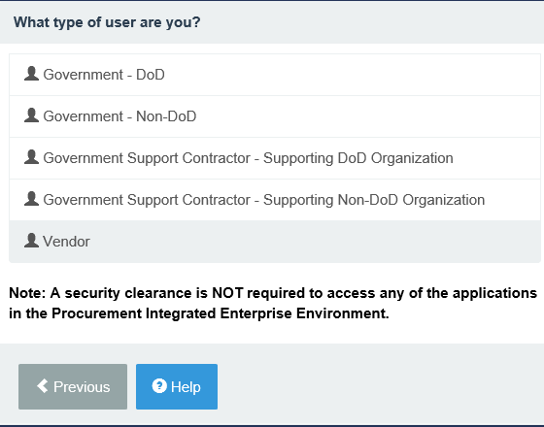

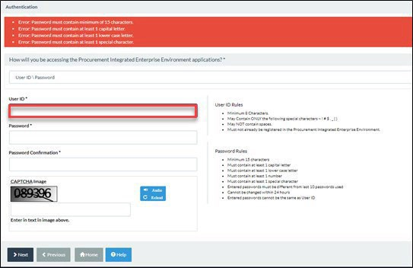
Enter a User ID, Password, and CAPTCHA text. Then, select Next.
You cannot change your User ID once you register.

- Create your security questions. Then, select Next.
  - Security Answers must be unique.
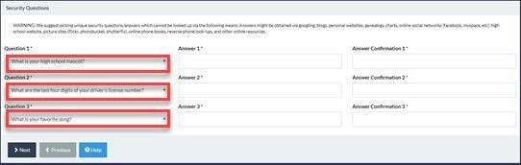
- Complete your User Profile. Then, select Next.
  - Required fields are marked with an asterisk (*).
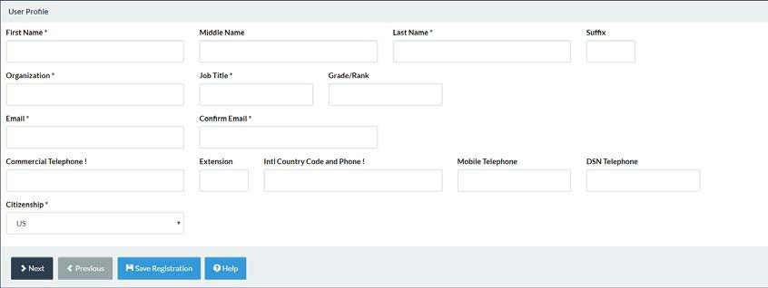
6. Complete your Supervisor and Company Information. Then, select Next.
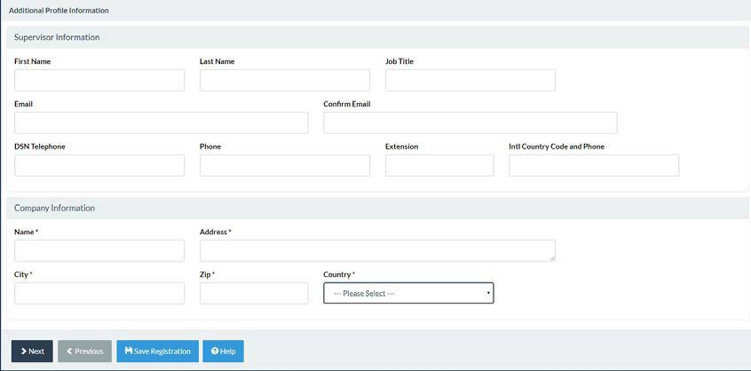

- Complete Roles. Then, select Next.
  - Step 1. Select SOL - Solicitation from the dropdown.
  - Step 2. Select Proposal Manager (or Proposal View Only).
  - Step 3. Click Add Roles.
  - Step 4. Enter your CAGE Code in the Location Code field.
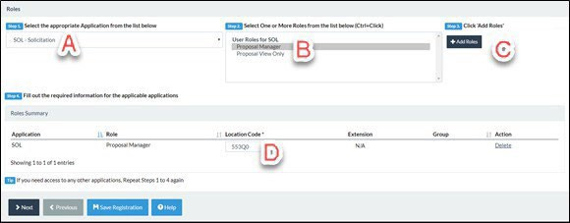
8. Enter a justification for access and upload any necessary attachments. Then, select Next.
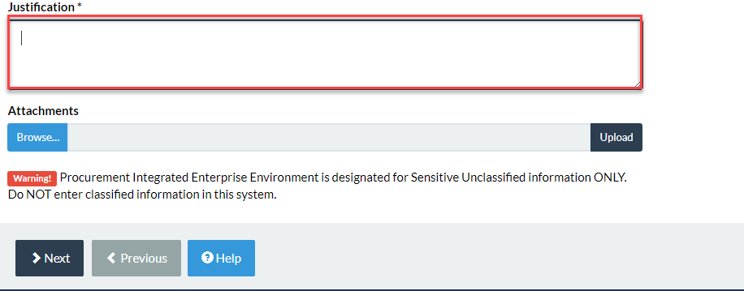

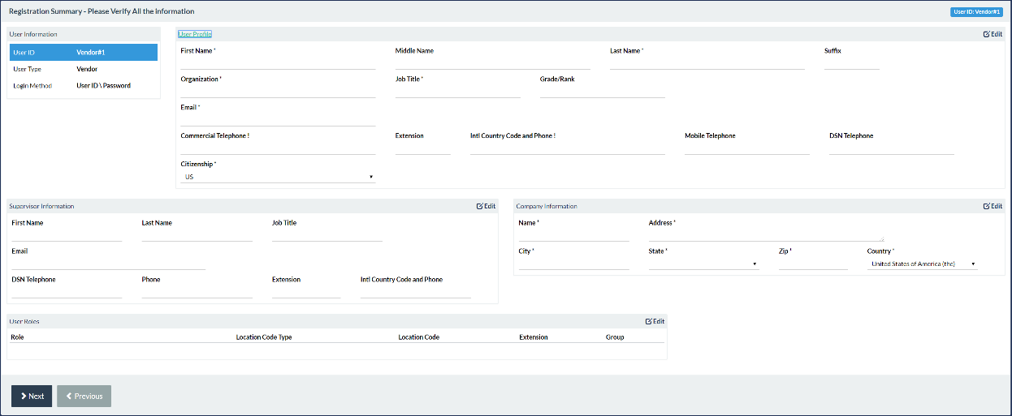
9. Verify the information on the Registration Summary page is correct. Then, select Next.

- Review the Statement of Accountability Agreement. Then, select Signature.
  - The ‘Password Confirmation’ modal window will appear.
  - Enter password created in Step 3.
  - Click Submit Registration.
 | 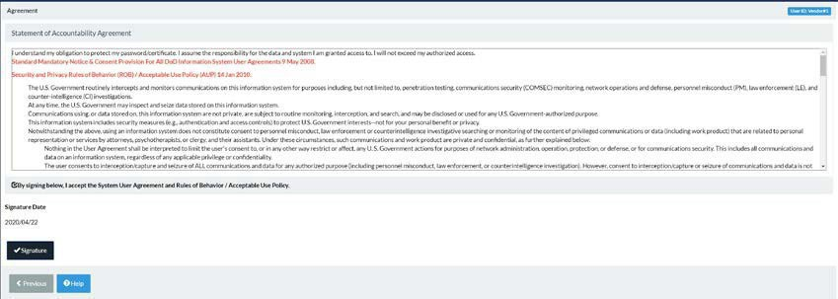
11. You will see a success message that your registration was successful. You will receive a confirmation email shortly. Once your account has been activated by an Account Administrator, you can login into PIEE. |  | 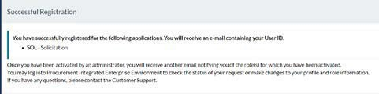

Existing User
Follow the steps to add additional roles (Proposal Manager, Proposal View Only) to your PIEE user account.

12. After logging into PIEE, click My Account (Top Left) |  | 
13. Select Add Additional Roles.
 | 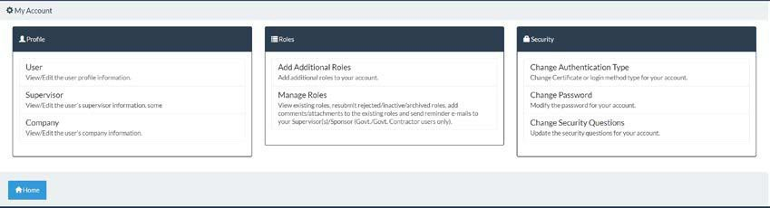
14. Verify all profile information within your account is up-to-date. Then, select Next.
 | 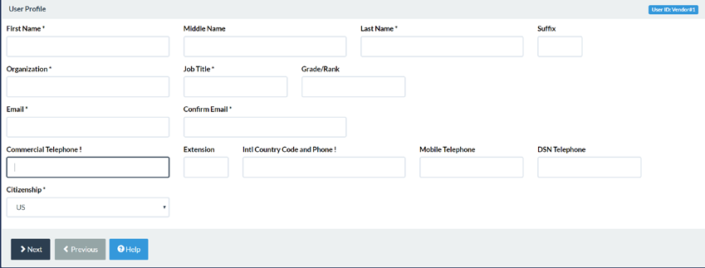
15. Follow Steps 7 - 10 above.
16. You will receive a confirmation email that the new role(s) were activated by your Account Administrator.
 | 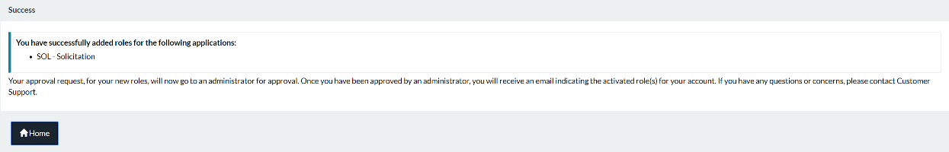

Help

Getting Started
If your company is new to PIEE and has no Account Administrator, the link below provides the general steps in getting started as a vendor to use the PIEE Solicitation Module and other PIEE applications:

https://wawf.eb.mil/xhtml/unauth/web/homepage/vendorGettingStartedHelp.xhtml

Account Support
Your company’s Account Administrator can help you view or edit profile information, reset a password or certificate. You can enter your five-character CAGE Code to find your company’s Account Administrator at the link below:

https://wawf.eb.mil/xhtml/unauth/lookup/gamLookup.xhtml

Technical Support
If you are experiencing technical problems with PIEE and your company’s Account Administrator cannot resolve, please contact the DISA DECC Ogden Electronic Business Service Desk or visit the link below and click "Ogden Help Desk" to submit a ticket.
https://wawf.eb.mil/xhtml/unauth/web/homepage/vendorCustomerSupport.xhtml

Email: disa.global.servicedesk.mbx.eb-ticket-requests@mail.mil Phone: 866-618-5988, 801-605-7095

Roles and Actions/Functions Matrix
The Roles and Actions Matrix provides a depiction of the available actions for each vendor role.

Action | Role(s)
Submit Offers | - Proposal Manager
View Offers | - Proposal Manager  - Proposal View Only
Posts Offer Revision | - Proposal Manager

Menu Item | Role(s)
Create Unsolicited Proposal | - Proposal Manager

Search | - Proposal Manager  - Proposal View Only
Lookup Product/Service Codes | - Proposal Manager  - Proposal View Only
Lookup NAICS | - Proposal Manager  - Proposal View Only

The Roles and Functions Matrix provides a depiction of the Menu Items available for each vendor role.

Appendix 2 – Cross Reference Matrix
Subparagraphs may or may not apply. See specific instructions in the Section L paragraphs for details.

Cross Referencing Matrix

Offeror’s Proposal Section L Section M SOW Paragraph Vol Paragraph Number(s)
Price Factor, 4.0 3.0 15.4.3 I

Total Evaluated Price (TEP), 4.1.1
Seed Project Pricing, 4.1.2
Wage Determinations, 4.1.7
3.0.1.4 I

3.0.1.8 I

3.0.1.6 I

Technical Factor, 5.0 4.0 7.0 II

Subfactor 1, Seed
Project, 5.2.1
Material, 5.2.1.1
Concrete/Backfilling 5.2.1.3
Electrical, 5.2.1.5
Plumbing, 5.2.1.6
Subfactor 2: Subcontractor Utilization Plan, 5.2.2
Subfactor 3: Management Plan, 5.2.3
Past Performance Factor, 6.0
Recency, 6.1.1
Relevancy, 6.1.2
4.0.1.2

4.0.1.2.1
4.0.1.2.3

4.0.1.2.5
4.0.1.2.6
4.0.1.3

4.0.1.4

5.0

5.0.1.1.1
5.0.1.1.2
1.3, 7.0, 21.0

21.0

6.0

5.0

16.3
II II II II II II

II

III III III

Past Performance Discrepancy, 6.1.3 | 5.0.1.1.3 |  | III
Contract Documentation, 7.0 | 6.0 |  | IV
Contractor Responsibility, 8.0 | 7.0 |  | IV
Limitations on Subcontracting, 8.1.2 | 7.0.11 | 4.6 | IV
Bona Fide Office, 8.1.3 | 7.0.1.2 | 3.0 | IV
CMMC, 8.1.4 | 7.0.1.3 |  | IV

