Performance Work Statement (PWS)
Gun Lockboxes for OPNAV N17

Background

As part of the Navy’s Lethal Means Safety Initiative (LMS), this year’s LMS product will feature gunlock boxes. CONUS Fleet and Family Support Centers (FFSCs) are designated as LMS distribution sites for Sailors, family members, command leaders, Suicide Prevention Program Managers (SPPMs), and Suicide Prevention Coordinators (SPCs). Although Gun locks are effective and inexpensive, lock boxes are frequently requested.

In July 2025, the Navy conducted an online survey to learn about the Navy community’s awareness of current lethal means safety programs, preferences for safety devices and safe storage locations. Sailors were asked to indicate their preferences for LMS storage solutions: Small gun lockboxes were the preferred storage choice among survey respondents. Research shows that creating time and distance between suicidal thoughts and access to lethal means saves lives. To support this effort, OPNAV N17 (Navy Culture & Force Resilience) is acquiring 25,000 gun lockboxes for Sailors. The contractor will handle the full supply and delivery of these units in line with the requirements in this Performance Work Statement.

Scope of Work

The contractor shall provide quality gun lockboxes and manage the associated logistics, including packaging and shipping as described herein. The objective is to ensure the timely delivery of approximately 25,000 gun lockboxes to forty (40) CONUS (continental U.S.) Navy sites.

The purpose of this initiative is to assist Sailors and their families during emotional or stressful times to avoid irreversible actions to end their lives and provide the opportunity for intervention and care.

Product Description and Requirements:
Navy Suicide Prevention intends to procure gun lockboxes to promote firearm safety within the fleet in alignment with the “Joining Your Fight: Connect to Protect”, campaign, which underscores the vital role strong connections such as family, friends, and community members play in preventing suicide.
Below are the production requirements for the gun lockboxes, including size, type, and branding. The vendor will provide price estimate per lockbox. Costs for shipping will be included within the overall cost. Shipping must begin by October 2026, and all deliveries completed by February 2027.
The vendor must provide gun lockboxes in accordance with the specifications and pictures herein:

Product Description/Specifications:
- The lockbox should be black and of metal construction.
- The lockbox should include a keyed lock with the lockboxes not keyed alike.
- The lockbox should have an internal hinge mechanism to make it more difficult for someone to break into.
- The lockbox should include a “crinkle finish” on the coating to avoid fingerprints and scratching. These coatings should be fully compliant with all applicable standards.
- The lockbox should include an attachment cable and a method to permanently affix the lockbox to avoid someone stealing the lockbox with the firearm inside.
- The interior of the lockbox should be padded to prevent damage to any firearm.
- The size of the lockbox should be such that it accommodates a small pistol.
- The front of the lockbox should include a laser engraved logo, “America’s Navy” “Forged by the Sea” with the Veterans/Military Crisis Line Info towards the bottom right (as pictured below).
- Inside the lockbox will include a magnetic picture frame that can support at least a 4” X 6” picture of a loved one.
- The supplier should provide a complete kit composed of the lockbox, picture frame, and printed carton.
- The supplier should be able to distribute to the various bases in small quantity shipments.
- The Lock box must contain 2 keys. Egg crate foam in bottom half and flat foam in top half/lid, 2 drywall anchors and screws to secure metal lockable case to a flat surface, 36” long security cable option, 2-color printed white product carton

Gun Lock Box Pictures:

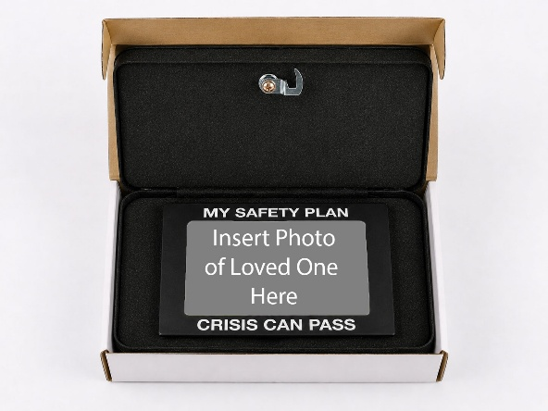
Loved one frame should support at least a 4 X 6 photo. The outer edge of the frame should read: “MY SAFETY PLAN” at the top of the frame and “CRISIS CAN PASS” at the bottom of the frame. The Loved one frame must be affixed to the TOP inside lid of the lockbox. The photo should be able to slide in from either the top of the frame or the side.
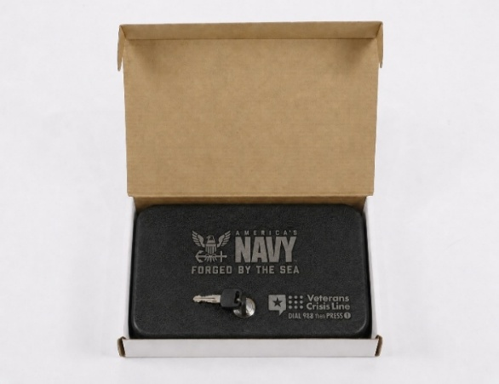
OPNAV N170B will provide the final spreadsheet with price, addresses and quantities per shipping location provided upon award
Shipping/Packing Specifications

- Lockboxes and all necessary elements are to be individually packaged together
- Instructions for use are to be included in the packaging with each Lockbox.
- Bulk packaging should include clear markings indicating “Navy Lethal Means Safety
Campaign (Lockboxes)” this is to avoid confusion of shipment contents.
- “Made in China” marking should be placed in an inconspicuous area on the product.
- Provide delivery confirmation for each location.

Packing Specifications

- Lockboxes to be packed 16 per carton unless requested otherwise:
- 20” L x 15” H x 10.25” W @ 42 pounds each.

Contracting Officer Representative:

Victor Gooden
OPNAV N17, Navy Culture & Force Resilience Office
Navy Suicide Prevention Office N170B
Phone: 901-874-4220 | DSN 882-4220
Email: victor.gooden.civ@us.navy.mil

Contract Office POC:

Julia Ledbetter
Contract Specialist
Email: julia.h.ledbetter.civ@us.navy.mil

Christopher Daubert
Contract Officer
Email: christopher.w.daubert.civ@us.navy.mil

