Coconino National Forest
Flagstaff Ranger District
FLAGSTAFF RANGER DISTRICT WASTEWATER IMPROVEMENTS
July 2024

STATEMENT OF WORK
Project:

- Description: This Statement of Work (SOW) outlines the tasks to consist of the construction of a new sewer collection system includes connecting existing facilities, installing sewer mains and sewer manholes, and restoring surfaces to preconstruction conditions. This will include permitting with ADEQ through the City of Flagstaff and associated fees. Project can start in spring 2026 and continue up to the connection point but would have to wait to complete the final connection until the Wildcat Sewer Upsizing project is completed and accepted by ADEQ expected in late 2026

- This project is comprised of all required labor, equipment, and materials necessary to perform all the work included in the schedule of items, drawings, and specifications.

- Work includes but is not limited to:
  - mobilization,
  - construction survey and staking,
  - traffic control,
  - soil erosion and sediment control,
  - paved street and surface restoration,
  - unpaved street surface restoration,
  - native ground surface restoration,
  - seed and fertilize,
  - urban trail restoration,
  - curb and gutter restoration,
  - clearing and grubbing,
  - 8” sewer mains and crossings,
  - 48” manholes,
  - connect to existing manhole,
  - drop sewer connection outside manhole,
  - 4” sewer service laterals,
  - sewer service cleanouts,
  - sewer service connection,
  - abandon existing septic tanks,
  - existing water and gas main crossing

- The intent of the Contract is to provide for the complete construction of the project described in the Contract documents. Unless otherwise provided, the Contractor is to furnish all labor, materials, equipment, tools, transportation, and supplies and perform all work required to complete the project in reasonably close conformity with the drawings and specifications, and in accordance with the provisions of the Contract. Payment for Contract work will be made only for and under those pay items included in the Schedule of Items. All other work and materials will be considered as incidental to and included in the payment for items shown.

- Specific requirements can be found on the attached Flagstaff Ranger Station Wastewater System Improvements Drawings, and Technical Specifications for Flagstaff Ranger Station Wastewater System Improvements.

- The project site is located on the Coconino National Forest, Flagstaff Ranger District off East Marketplace Dr on the northeast side of Flagstaff, Arizona.

  - Head west toward S Thompson St
269 ft
Turn left onto S Thompson St
0.1 mi
Turn left onto W University Ave
0.2 mi
Turn right onto W Forest Meadows St
0.8 mi
Turn right onto S Milton Rd
0.2 mi
Take I-40 E to I-40BL/N Country Club Dr. Take exit 201 from I-40 E
6 min (6.4 mi)
Continue onto I-17 S
0.4 mi
Take exit 340A to merge onto I-40 E toward Albuquerque
5.8 mi
Take exit 201 toward US-89 N/Page
0.3 mi
Continue on I-40BL/N Country Club Dr to your destination
5 min (1.3 mi)
Use the middle lane to turn left onto I-40BL/N Country Club Dr
0.5 mi
Use the 2nd from the right lane to turn right onto N 89
0.4 mi
Turn left onto E Marketplace Dr
495 ft

Turn right onto Forest Service Rd 989C
0.2 mi
Turn right

LATITUDE 35.228716° LONGITUDE -111.580327°

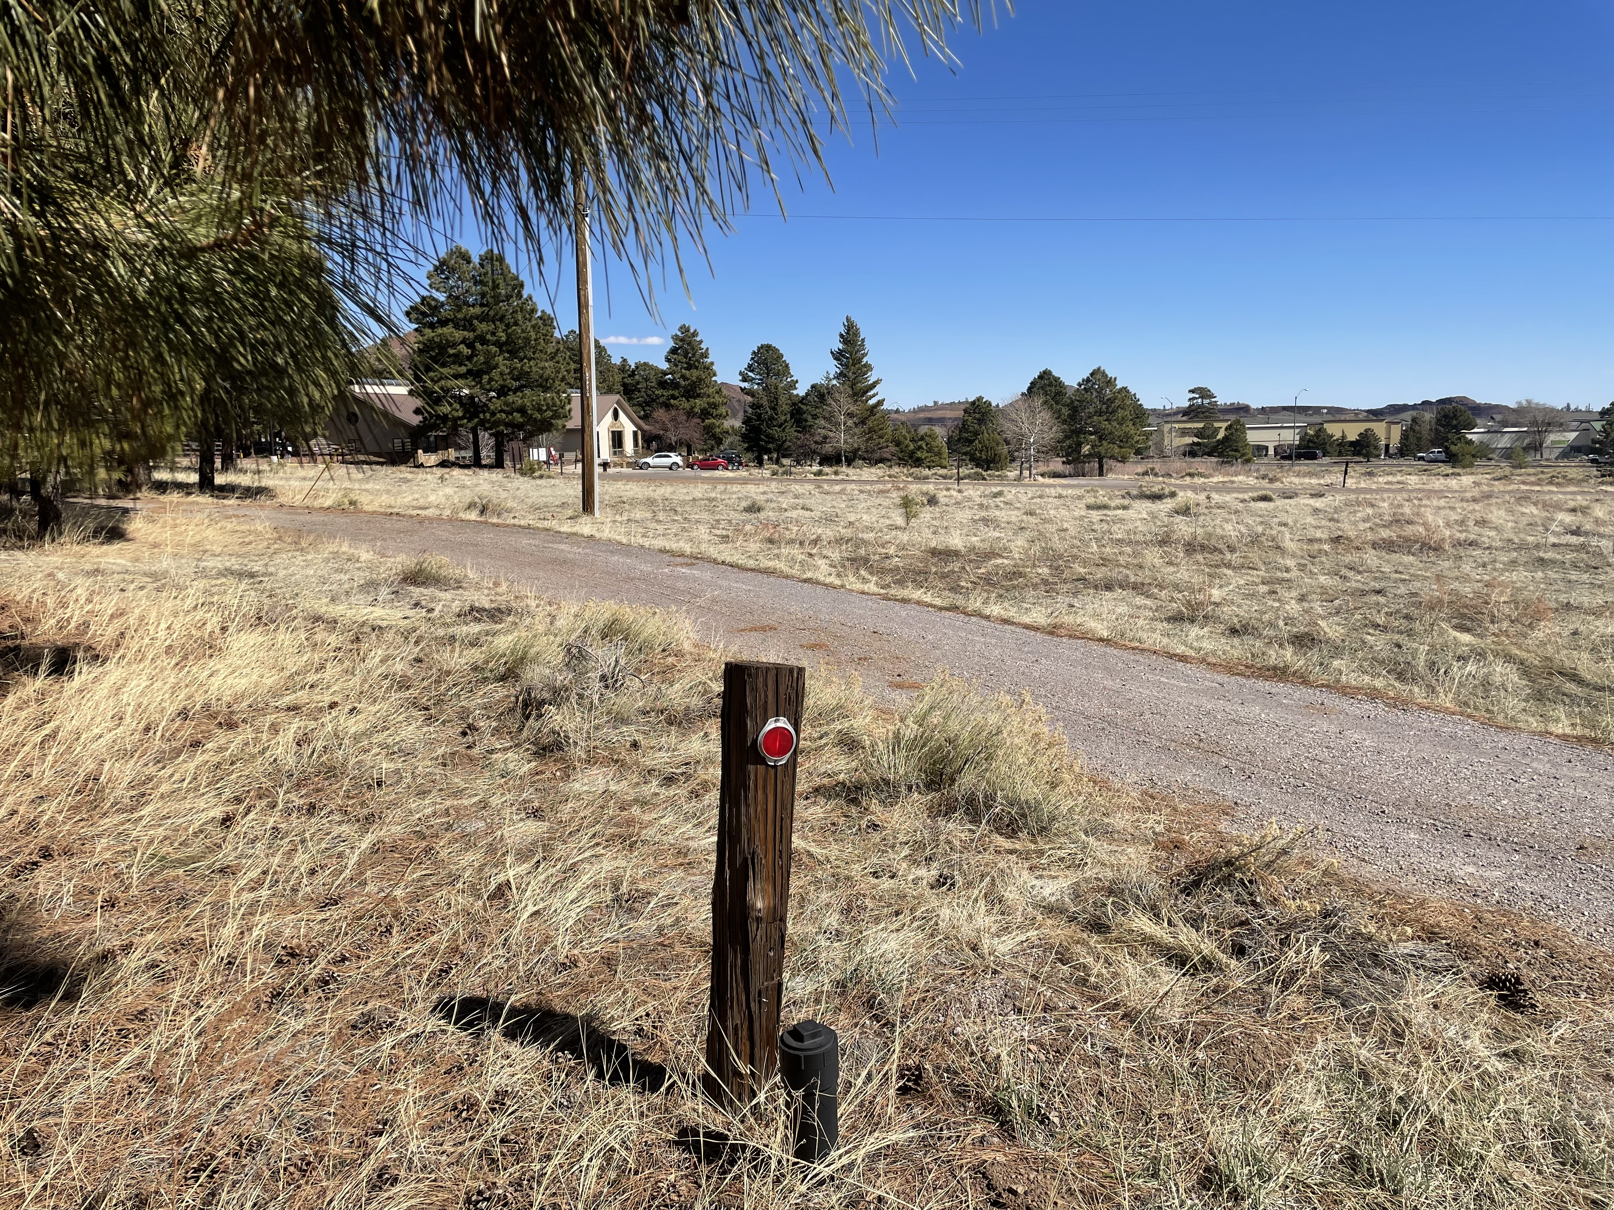
Existing office building.
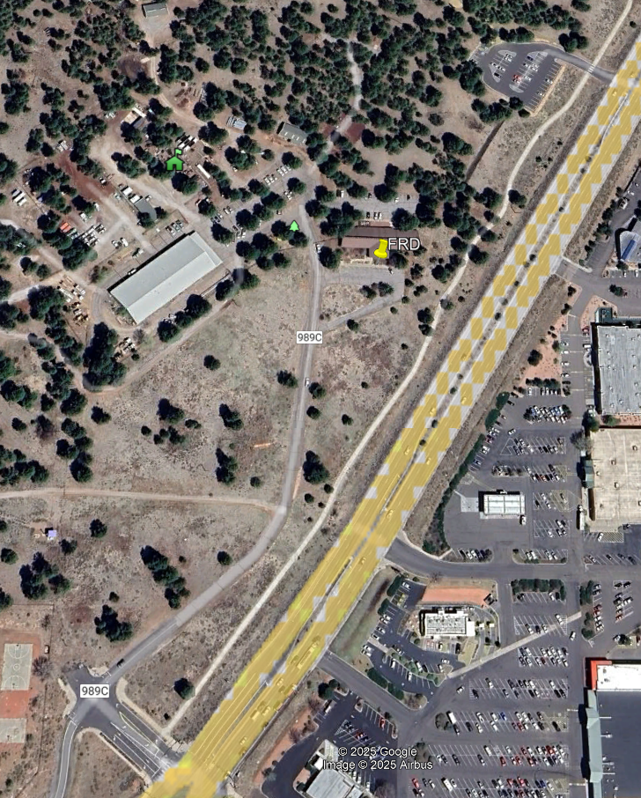
Existing Flagstaff Ranger Station site.
8. Performance Time: Construction shall occur after the notice to proceed is issued expected in Spring 2026, coordination will need to occur with the forest service as this is an active administrative site and activities are expected during the life of the contract. The entire wastewater system can be constructed up to the connection point but would have to wait to complete the final connection until the Wildcat Sewer Upsizing project is completed and accepted by ADEQ expected in late 2026. Normal work shall occur weekdays between 7am and 6 pm, weekends and/or Government Holidays will not be allowed unless approved by the CO. During critical phases of construction, allowances may be made to perform necessary work outside of normal hours and/or on weekends at the written approval of the CO. Specific work schedule requirements can be found in the specifications for the project. Total length of contact is 575 calendar days from issuance of Notice to Proceed.

9. Permits Required: The contractor shall be responsible for obtaining all necessary licenses and permits for construction of the new wastewater system improvements. A submission to ADEQ will be required for the sewer main extension. This will be done via an account the city has set up with ADEQ to submit the required documents. ADEQ has an online portal that all the required documents will need to be uploaded to. The city will issue public improvements permit that will cover the city’s inspection costs on the project and allow for the work in the Right of Way. ADEQ will issue a construction authorization after reviewing the NOI permit application and issue a discharge authorization at the end of the project once all required testing is completed and accepted. There are three forms expected to be needed are: Notice of Intent to Discharge Sewage Collection System (1.01 GP), Capacity Assurance Sewage Treatment Facility, and Notice to proceed will not be given until all permits are received.

Background Information:

This site is located on the Flagstaff Ranger District on the east of Flagstaff and is a very active administrative site. There are a total of six main buildings onsite: the main office, a large warehouse/office, flammable storage building, barn, small multipurpose storage building, and open carport, along with many Connex storage type containers. The site is served by City of Flagstaff water, power by Arizona Public Service, and natural gas. There are 5 existing septic tank systems that serve the office, warehouse, and several recreation vehicle pads.
The site was built in the mid to late 1980’s and the number of employees has grown over the years. The septic tank systems have exceeded their design life, and we can connect to the City of Flagstaff wastewater system

Site Visit:
Bidders are urged and expected to inspect the site where the work will be performed and to satisfy themselves regarding all general and local conditions that may affect the cost of contract performance, to the extent that the information is reasonably obtainable. In no event shall failure to inspect the site constitute grounds for a claim after Contract award.

Construction Specifications Institute (CSI):
- The Construction Specification Institute was used for this building project. The project construction documents contain specifications for Division 01 – 03, Division C. The Specifications are physically located in an attachment to the solicitation.

Safety and Public Notification:
- Warning signs will be placed at the proper locations to warn public/employees of work and construction traffic. All signs shall meet the minimum requirements as established by the Manual of Uniform Traffic Control devices (MUTCD), 2009 edition. The current MUTCD can be obtained online at: http://mutcd.fhwa.dot.gov/kno_2009r1r2.htm.
- A notice of where and when the public might expect delays due to project work will be posted on access roads to the project. Proper posting and maintenance of warning signs is the responsibility of the contractor.
Damage to Structures:
The Contractor shall be held liable for any damage caused by his/her personnel to any existing infrastructure on the administrative site not included in the contract. Repair of structures damaged by the Contractor’s operations, shall be their responsibility at no cost to the Government.

Submittals and Notifications:
The following required items need to be submitted according to the document list to prevent delays or stoppages of work.

Flagstaff Ranger Station Wastewater System Improvements Drawings, and Technical Specifications for Flagstaff Ranger Station Wastewater System Improvements.

Notification Schedule:
The following events require an advance written notification to the CO. Notifications may be faxed, mailed, emailed, or hand delivered.

 | EVENT | PRIOR NOTICE REQUIRED
o | Change in Schedule | As soon as identified
o | Intent to mobilize | 48 hours
o | Intent to start excavation | 48 hours
o | Intent to place concrete | 48 hours
o | Intent to test utilities | 48 hours
o | Intent to place asphalt | 48 hours
o | Intent for wastewater system by City of Flagstaff | 48 hours

Drawings:
Entitled “Flagstaff Ranger Station Wastewater System Improvements”. The following drawings are a part of this solicitation and any resulting contract. The Drawings are physically located in an attachment to the solicitation.

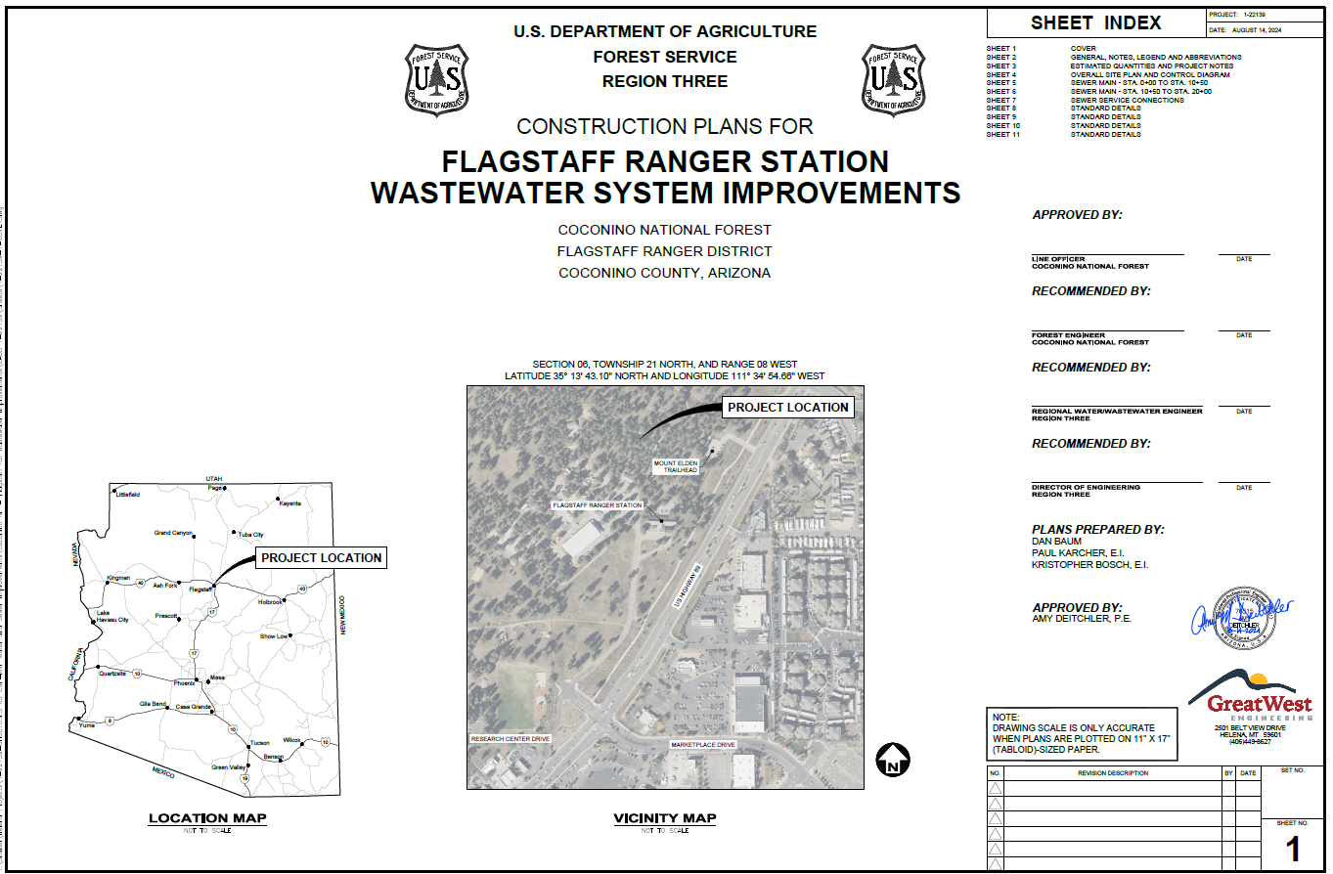

Sanitary Facilities:
Sanitary facilities for workers will not be available at the Flagstaff Ranger Station site and must be provided by the contractor.

Utilities:
No utilities are available at the project site.

Inspections:
Inspections will be performed by the government and City of Flagstaff by the COR or designated inspector. The wastewater system will require City of Flagstaff inspection to adhere to the permit.

Tasks

The Contractor shall provide all labor, materials, tools, equipment, services, testing, supervision, and incidentals necessary to perform activities associated with the construction required for the Flagstaff Ranger Station Wastewater System Improvements.

All tasks and work must meet technical requirements contained in the project construction documents. These documents include the drawings, technical specifications, and any required permits. Technical Specifications include the following divisions 1-3 and C, geotechnical report, and special provisions:
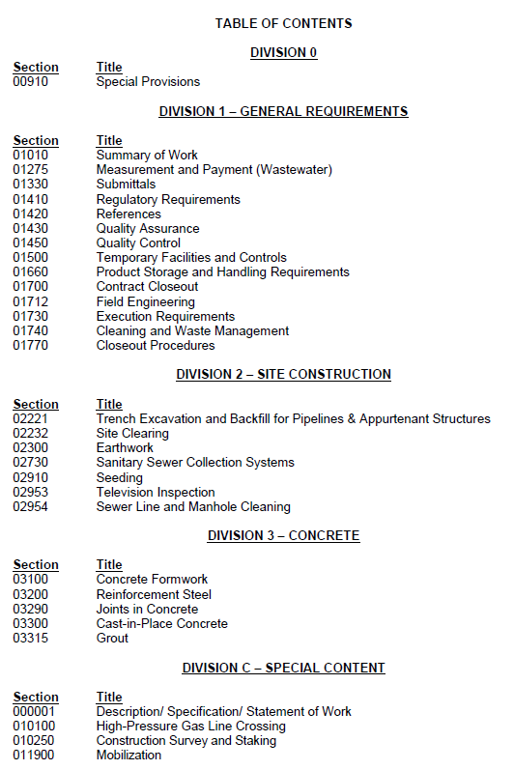
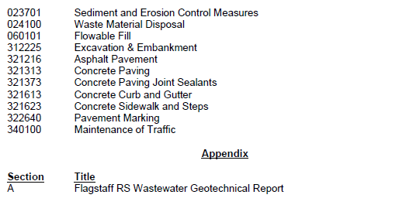
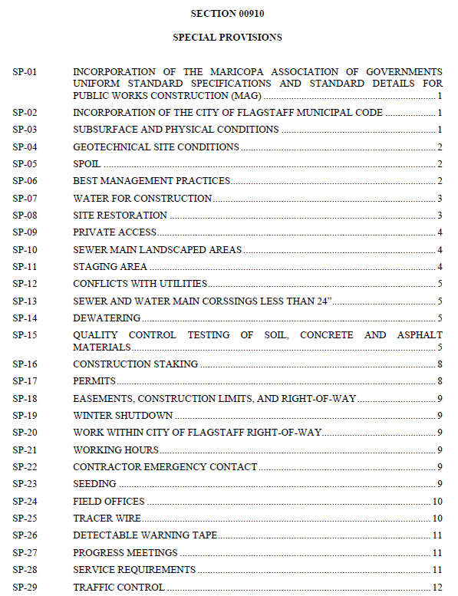
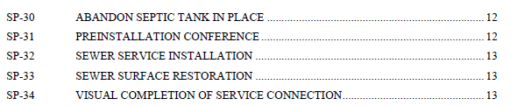

The contractor shall comply with the Federal Regulatory Agencies: U.S. Environmental Protection Agency (EPA), U.S. Housing and Urban Development Agency (HUD), U.S. Occupational Safety and Health Administration (OSHA), U.S. Department of Transportation (DOT), U.S. Department of Health and Human Services (HHS), U.S. Department of Labor (DOL). They shall also comply with local and State laws, regulation, and regulatory agencies; and Arizona Department of Environmental Quality (ADEQ).

The contractor shall adequately protect the work sites, surrounding lands, employees, and public during the entire length of the project. The contractor shall be responsible for all damages or injury caused due to their actions or negligence.

Pay Items are outlined in the Schedule of Items.

Contacts
COR:
Ray Holt, Supervisory Civil Engineer
(928) 527-3524
raymond.holt@usda.gov

Project Inspector:
Kristina Brown, Civil Engineer
(928) 522-3332
kristina.brown2@usda.gov

